SRS documentation

on

Pharmacy Management System

Filed: January 1st 2025

**Submitted by:**

Moaz Ibrahim

Mohamed Ibrahim

Mohamed Abdalla

Mostafa Osama

Ahmed Shamh

Shahd Ahmed

Hagar Ayman

**Under supervision of:**

ENG/Ahmed madkour

Table of Contents

1. INTRODUCTION
   * 1. PURPOSE
     2. SCOPE
     3. Definitions, acronyms, and abbreviations
     4. References
   1. Overview write in terms of chapters/sections
2. OVERALL DESCRIPTION
   1. Product Perspective
   2. Product Features
   3. User Classes and Characteristics
   4. Operating Environment
   5. Design and Implementation Constraints
   6. User Documentation
   7. Assumptions and Dependencies
3. USE CASE DIAGRAM WITH USE-CASE DESCRIPTIONS

Use case diagram

Use case descriptions

1. EXTERNAL INTERFACE REQUIREMENTS
   1. Login Page
   2. Pharmacy Home Page
   3. Billing System Page
   4. Staff Management Page
   5. Expired Medications Page
   6. Request Page
   7. Report Page
   8. Electronic Prescription Page
2. CLASS DIAGRAM
3. SEQUENCE DIAGRAM
4. DATA FLOW DIAGRAM
5. PROCESS SPECIFICATION

**INTRODUCTION**

# **PURPOSE**

The purpose of this project is to develop a software that connects doctor and pharmacy to speed and improve medicine purchasing process. Effective management of a pharmaceutical store that will be able to achieve the following objectives: Ensuring effective policing by providing statistics of the drugs in stock Maintaining correct database by providing an option to update the drugs in stock. Improving the efficiency of the system by ensuring effective monitoring of services and activities.

To provide optimal drug inventory management by monitoring the drug movement in the pharmacy. To ensure that there exists a level of restricted access based on functionality and role. To be able to generate report within a specified period of time. To ensure high quality treatment. [1]

# **Scope**

* Pharmacy Management System (PMS) is a desktop-based application designed to simplify and automate the operations of pharmacies in [Your Location]. This system provides robust features to manage inventory, prescriptions and sales while maintaining high efficiency and accuracy in day-to-day operations. The application is compatible with Windows, macOS, and Linux operating systems, ensuring accessibility for diverse users.
* Secure payment processing through cash, card, or integrated third-party payment services. Automatic record-keeping of all transactions for auditing purposes.
* Pharmacy managers can monitor inventory levels, sales trends, and staff performance (update, remove, get info and search), Generate detailed reports for daily, weekly, or monthly sales and inventory tracking.
* A locally hosted or network-connected database store inventory data, and financial transactions securely.
* The system aims to ensure optimal performance and adaptability to evolving user needs, the application must undergo continuous updates and modifications.
* The system allows user to switch languages easily, allows user to log in using social media accounts like Facebook or Google.
* New functionalities and improvements will be added to meet user demands and enhance user experience.

# **Definitions, acronyms, and abbreviations**

|  |  |
| --- | --- |
| TERM | DIFINITION |
| PMS | Pharmacy Management System |
| GUI | A graphical user interphase is a user interface that allows users to interact with digital system through visual and graphical elements rather than text-based commands |
| macOS | The operating system developed by Apple. It is the primary operating system for Apple's Mac computers. |
| SRS | Software Requirement Specification |
| SQL | Structured Query Language (SQL) is a standard language for storing, manipulating and retrieving data in databases |
| MySQL | MySQL is an open-source relational database management system we can interact with using (SQL). |

# **References**

[1] <https://www.studocu.com/my/document/universiti-tenaga-nasional/requirements-engineering/srs-pharmacy-management-system/40456838>

[2] <https://pdfcoffee.com/pharmacy-management-system-srs-pdf-free.html>

# **Overview**

This Software Requirements Specification document consists of 8 main chapters. Among those 8 chapters, the first is an overall summary to the project. The second chapter discusses about the product perspectives such as what does it offer and how is it supposed to perform. The third expands the previous chapter into scenarios of which the user might face while using the app. The forth is a detailed explanation to guide users throughout the interfaces while maintaining simplicity of the terms. The fifth chapter is a static representation of the main functions, classes, attributes, illustrating their relationships and source code dependencies among classes. Sequence Diagram is the dynamic description of the process and how are the methods to react when there is an input. Dataflow diagram is discussed throughout the seventh chapter to explain full system process and input and output of each entity. Lastly processing specification is to be carried out at chapter eight to outlining the business procedure that each elementary level business activity is expected to carry out

**OVERALL** **DESCRIPTION**

The Overall Description section in a Software Requirements Specification (SRS) document provides a high-level overview of the product, outlining its primary purpose, goals, and the environment in which it will operate. This section sets the stage for detailed technical and functional requirements by offering context and understanding of the product's role and importance.

1. **Product Perspective**

The PMS is designed to operate as a key module within a pharmacy's broader technology ecosystem. It is built to support efficient medication to check on Expiry data, inventory control to check on MEDs needed available or to be added, with the flexibility to integrate with related systems and adapt to various deployment environments. The environment in which the PMS will operate is Pharmacy, the PMS

Mainly consists of User Interface, Database. Through user interface Interacts

1. Pharmacists: Dispensing medication, inventory control.
2. Administrators: Full access to all system features, including reporting, user management, and system settings.
3. Doctor: sends a list of medications the patient needs to the pharmacy and checks whether these medications are available in the pharmacy or not
4. **Product Features**
   1. **Core features**
      1. **VIEW, MODIFY AND DELETE INVENTORY**

* Generates report weekly on information about the drugs and it exports the information as output document. [2]
* Allows the pharmacist to view inventory and identify expired medications.
* Allows Manager to track and manage inventory effectively. It can set low-stock alerts and monitor stock levels in real time. [2]
* Manager is responsible for creating and maintaining the various subscription plans for the patrons.
* Manager can view, modify and delete medicine in the pharmacy.
  + 1. **SYSTEM MAINTENENCE**
* Applicate to perform optimally and to meet changing user requirements, it must be modified continuously.
* Corrective maintenance will be made to changes discovered that can cause malfunctioning of the system
  + 1. **STAFF MANAGEMENT**
* Each staff member has unique login credentials and restricted access based on their role.
* Manager can add, edit, or remove staff members with role-based access.
* Manager can assign work shifts or schedules to each staff member.
* Manager can monitor and review staff performance based on attendance, tasks completed.
  + 1. **EXPIRED ITEM IDENTIFICATION AND MANAGEMENT**
* The system tracks expiration dates for medications.
* Sends regular alerts to system administrators or users about medications nearing expiration.
* Filters out expired products and removes them from stock
  + 1. **Electronic prescription pick up**
* PMS will quicken the process of collecting medications
* Cut-down on time spent searching for locations that stock the prescribed medications
* Prevents patients from accessing over-the-counter medications without proper authorization
  1. **Additional features**
     1. **SET/REMOVE DEFAULT LANGUAGE**
* Allow users to select a default language for the interface.
* Users can switch languages easily, but this feature is not a core requirement for the system.
  + 1. **USER LONGIN VIA SOCIAL MEDIA**
* Allow users to log in using social media accounts like Facebook or Google.

This is convenient for some users, but not essential for a pharmacy system.

1. **User** **Classes and Characteristics**

This section identifies the main categories of users and their typical roles in a pharmacy setting. For each class, their specific characteristics and functionalities are detailed below

* 1. **MEDICINE**
* The system allows users to search for medicines by (name or id) to locate them quickly.
* Users can see the ID and expiry date of every medicine in the inventory, ensuring that expired medicines are not sold.
* The system will provide a precise information about quantity and last updated prices for every medicine in addition to inform the system user about lack of any medicine and every update in the inventory.
* The system empowers users to efficiently update medicine information, ensuring swift corrections to any inaccuracies in the database entries. This feature guarantees accurate and reliable inventory records for seamless pharmacy operations.

* 1. **PHARMACY STAFF**
* The Process Impact Pharmacy employs approximately 10 staff members who are responsible for receiving customer orders, retrieving medicines, packaging them for delivery, and coordinating the delivery process.
* Most of the Pharmacy Staff will need training in the use of the hardware and software for the system to use the full advantage of it.
* Doctor can make requests to the pharmacy through the system which provides an easy way to get the medicine streamlining the process and improving customer experience.

* 1. **SUPPLAYER OF MEDICINE**
* All the payment functions for the medicine orders will be processed by the Payroll department.
* Payment can be done in various methods including (FAWRY POS, VODAFONE CASH, MASTER CARD, and VISA).
* A payroll processor verifies the payment details provided by the user and approves the payroll.
* Post the payroll approval from the payroll processor, the order transaction for the order
* Will be processed and the order placed by the user will be successful.
  1. **PAYROLL DEPARTMENT**
* All the payment functions for the medicine orders will be processed by the payroll department.
* The payroll processor reviews the user's payment details and authorizes the payroll.
* After approval, the medicine order transaction is finalized, and the user's order is confirmed as successful.

1. **Operating Environment**

* **Windows 11**

1. **Design and Implementation Constraints**

|  |  |
| --- | --- |
| CONSTRAIN NUMBER | DESCRIPTION |
| Constraint 1 | The **PMS** code shall be programmed in python  programming language, considering the software’s  Flexibility to operating. |
| Constraint 2 | he system shall use (SQLite or MySQL) database for storing the information |

1. **User** **Documentation**
   1. **Steps to Add a New Employee**
      1. **Log in as Administrator (Admin)**

* Open the pharmacy application and log in using the admin credentials.
  + 1. **Access Staff Management**
* From the main menu, select the **Staff Management** option.
  + 1. **Add a New Employee**
* Click on the **Add Employee** button.
* Enter the required employee details, such as:
  + Full name.
  + Phone number or email address.
  + Job role (Pharmacist, Pharmacy Assistant, and Administrator).
  + Username and password for the new account.
  + ID
  + Working hours
    1. **Assign Permissions**
* Define the employee’s access level based on their role (e.g., view or Modify medicines, generate reports, etc.).
  + 1. **Save the Information**
* Click on the **Save** button to finalize the addition of the new employee.
* The system will successfully create the employee account.
  1. **Steps to Remove Employee**
     1. **Log in as Administrator (Admin)**
     2. **Navigate to Staff Management**
* From the main menu, select the **Staff Management** option.
  + 1. **Search for the Employee (Name or ID)**
* Use the search bar to find the employee you want to remove by entering their name or ID.
  + 1. **Select the Employee to delete**
* Click on the employee’s name from the search results to open their profile or details and click delete.
  + 1. **Confirm the Deletion**
* When prompted, confirm the deletion by clicking **Confirm** to finalize the process.
  + 1. **Verify Removal**
* Check the staff list to ensure the employee has been successfully removed from the system.
  1. **Steps to Add Medicines in the Pharmacy System**
     1. **Log in to the System**
* Open the pharmacy application and log in using your credentials with appropriate permissions (e.g., Pharmacist or Admin).
  + 1. **Access the Medicine Management Section**
* From the main menu, select Medicine Management or a similar option, such as Inventory Management.
  + 1. **Select the Add Medicine Option**
* Click on the Add Medicine button or tab.
  + 1. **Enter Medicine Details**
  + Fill in the required information, including:
  + Medicine Name.
  + Batch Number.
  + Manufacturer.
  + Expiry Date.
  + Quantity.
  + Unit Price.
    1. **Assign Medicine Category**
* Choose the appropriate category for the medicine (e.g., Painkillers, Antibiotics, and Supplements).
  + 1. **Save the Medicine**
* Click Save or Add to store the new medicine in the system.
  + 1. **Review the Medicine List**
* Check the inventory list to ensure the new medicine has been successfully added.
  1. **Steps to remove medicines**

1. **Log in as Administrator (Admin)**
2. **Access the Medicine Management Section**

* Navigate to the Medicine Management or Inventory section from the main menu.

1. **Search for the Medicine (Name or Batch number)**

* Use the search bar to locate the medicine by entering its name or any relevant identifier (e.g., batch number).

1. **Select the Medicine**

* From the search results, click on the medicine you want to remove to view its details.

1. **Click on the Delete Option**

* Locate and click the Delete Medicine or Remove button.

1. **Confirm the Deletion**

* When prompted, confirm the deletion by clicking Confirm to finalize the process.

1. **Verify Removal**

* Check the inventory list to ensure the medicine no longer appears in the system.
  1. **Steps to Remove medicines**

1. **Log in as Administrator (Admin):**
2. **Access the Medicine Management Section:**

* Navigate to the **Medicine Management** or **Inventory** section from the main menu.

1. **Search for the Medicine (Name or Batch number):**

* Use the search bar to locate the medicine by entering its name or any relevant identifier (e.g., batch number).

1. **Select the Medicine:**

* From the search results, click on the medicine you want to remove to view its details.

1. **Click on the Delete Option:**

* Locate and click the **Delete Medicine** or **Remove** button.

1. **Confirm the Deletion:**

* When prompted, confirm the deletion by clicking **Confirm** to finalize the process.

1. **Verify Removal:**

* Check the inventory list to ensure the medicine no longer appears in the system.
  1. **Steps to create a monthly report**

1. **Log in as Administrator (Admin):**
2. **Access the Reports Section:**
   * + From the main menu, select **Monthly Reports**.
3. **Select the Monthly Medicine Report Option:**
   * + Click on the **Generate Monthly Medicine Report** tab.
4. **Review Medicine Data:**
   * + The report will include the following details for each medicine:

* Medicine Name.
* Batch Number.
* Expiry Date.
* Starting Inventory.
* Quantity Sold
* Quantity Remaining.

1. **Analyze the Data**

* Evaluate the trends in medicine usage, such as:
* High-demand medicines.
* Expiring medicines.
* Low stock medicines.

1. **Save or Export the Report:**

* Save the report in the system or export it in a desired format (e.g., PDF, Excel) for record-keeping.
  1. **Steps to Process a Doctor's Request to the Pharmacy**

1. **Log in to the System as Doctor:**

* Open the pharmacy system application and log in using your credentials with appropriate permissions (Doctor).

1. **Access the Request Section:**

* From the main menu, select the **Doctor's Request** option.

1. **Initiate a New Request:**

* Click on the **Create Request**.

1. **Enter Request Details:**

* Fill in the required information, including:
* Doctor's Name.
* Patient Name.
* Request Date and Time.

1. **Search for medicine:**

* Click on the search for a medicine and search for the medicine you want

1. **Specify Medicines or Supplies Needed:**

* Provide details for each item requested, such as:
* Medicine Name.
* Dosage.
* Quantity Required.

1. **Submit the Request:**

* Click on the **Send to Pharmacy** button to forward the request.

1. **Pharmacy Verification:**

* The pharmacy team will:
* Review the request.
* Check the availability of the requested items.
* The doctor will receive a notification (Approved and ready for collection/delivery.)
  1. **Steps to Generate Billing**

1. **Log in to the System as a pharmacist or Admin.**
2. **Access the Billing Section:**

* From the main menu, select the **Generate new Bill** option.

1. **Add patient details to Bill:**

* Name.
* Age
* Phone Number.

1. **Add Medicines to the Bill:**

* Select the medicines or items to be billed.
* Enter the quantity for each item.

1. **Verify the Bill Details:**

* Review the following information before generating the bill:
  + Medicine Name.
  + Quantity.
  + Unit Price.
  + Total Amount.

1. **Generate the Bill:**

* Click on the **Generate Bill** button.
* The system will generate a unique billing ID for the transaction.

1. **Save and Print the Bill:**

* Save the bill in the system for record-keeping

1. **Complete the Payment:**

* Record the payment details, including:
  + Payment Method (Cash, Card, Insurance, etc.).
  + Payment Confirmation.

1. **Provide the Bill and Receipt:**

* Hand over the medicines and the bill to the customer/patient along with a receipt for the payment.

1. **Assumptions and dependencies**
   1. **Assumptions**

* The software will be operational from 8:00 AM to 12:00 PM, seven days a week.
* The application will be designed as a desktop application and will not require mobile or web compatibility.
* The user interface will be designed for ease of use, assuming basic computer literacy among pharmacy staff.
* The system will handle a manageable number of concurrent users within a single pharmacy.
* Data entered into the system will be accurate and reliable, as it directly affects inventory and prescription management.
  1. **Dependencies**
* A database system (SQLite or MySQL) will be required to store and manage all data related to inventory, sales, and prescriptions.
* The hardware requirements include a desktop computer with sufficient RAM and storage to run the application smoothly.
* The pharmacy must have an uninterrupted power supply to ensure the software remains functional during operating hours.
* The development and deployment process will depend on proper installation and configuration of all necessary software dependencies, such as the database and runtime environment.

**USE CASE DIAGRAM WITH USE-CASE DESCRIPTIONS**

* 1. 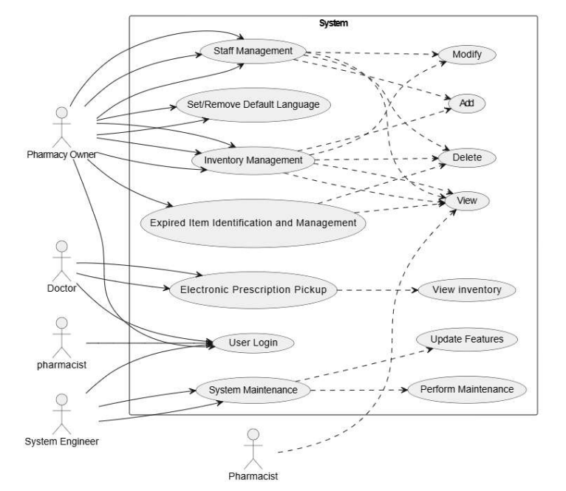**Use Case** **Diagram**
  2. **Use Case Description** 
     1. **VIEW, MODIFY AND DELETE INVENTORY**

|  |  |  |  |
| --- | --- | --- | --- |
| Use Case Id: | | UC-1 | |
| Use Case Name: | | Modify & delete and view inventory | |
| Created By: | Shahd Ahmed | Last updated By: | Moaz Ibrahim |
| Created Dated; | 26/11/2024 | Last revision Date: | 29/11/2024 |
| Actors: | | Owner of Pharmacy | |
| Description: | | This use case allows the Manager to effectively track and manage the pharmacy's inventory by viewing, modifying, and deleting medicines.  It includes generating weekly reports about drugs and exporting them as documents. The system also supports low-stock alerts and real-time monitoring of stock levels. | |
| Triggers: | | The Manager accesses the system to view, modify, or delete inventory items, or to review inventory status and generate reports. | |
| Precondition: | | The user must have a Manager account with the necessary access rights.  The pharmacy system must have an active internet connection for real-time monitoring and report exports. | |
| Post condition: | | Inventory data is updated as per the Manager’s actions (viewed, modified, or deleted).  Weekly reports are generated and exported successfully.  Low-stock alerts are set appropriately. | |
| Normal Flow: | | 1. Manager logs into the pharmacy management system. 2. View Medication List  * The admin accesses the "Inventory Management" section to view the list of current medications and their details (e.g., name, batch, expiry, stock levels).  1. Manager selects an option to:  * Modify details of an existing medicine. * .The admin modifies details of an existing medication, such as quantity, price, or expiry date. * Confirms the action and update the information of medication in the database. * Delete an existing medicine from the inventory. * The admin deletes obsolete or expired medications from the system. * Confirms the deletion action and the medication is deleted from the database. * Add New Medication: * The admin adds a new medication to the inventory by entering essential details like the drug name, batch number, quantity, expiry date, price, and supplier details. * Confirms the addition and the new medicine is added to the database.  1. The system displays the updated inventory. 2. Manager initiates the generation of a weekly inventory report. 3. The system generates and exports the report as a document. 4. Manager reviews and confirms the exported report. | |
| Alternative Flow: | | 1. Manager receives a low-stock alert for a particular medicine.  2. Manager adds a purchase request or updates the stock manually.  3. The system updates the stock levels in real-time. | |
| Exceptions: | | 1. Invalid password or username of Admin:  * The system display an error message telling the username or password is incorrect.  1. Invalid Data Entry:  * The user inputs invalid or out-of-range values, such as negative stock levels or invalid dates. * Resolution: The system displays an error if the user's newly entered information does not meet the required criteria.  1. Report Generation Failure  * The system notifies the Manager if there is an issue in generating or exporting the report.  1. Database Connection Error:  * If the system loses connection to the inventory database, actions such as adding, editing, or removing medication cannot be completed. * Resolution: The admin must wait for the connection to be restored or contact technical support. | |
| Includes: | | Username & Password & Granted Permission to edit  Weekly reports include details such as medicine name, stock levels, expiry dates, and sales trends. | |
| Frequency of use: | | Approximately 1 uses a day | |
| Assumption: | |  | |
| Priority: | | High | |

* + 1. **SYSTEM MAINTENENCE**

|  |  |  |  |
| --- | --- | --- | --- |
| Use Case Id: | | UC-2 | |
| Use Case Name: | | System Maintenance | |
| Created By: | Mohamed Ibrahim | Last updated By: | Mohamed Ibrahim |
| Created Dated; | 21/11/2024 | Last revision Date: | 28/11/2024 |
| Actors: | | Pharmacist / Owner of Pharmacy / SW Engineer | |
| Description: | | For the application to work well and adapt to user needs, it needs constant updates. Corrective maintenance fixes any issues that cause it to malfunction. | |
| Triggers: | | If any needed update on the system | |
| Precondition: | | If any issue prevents the system from functioning optimally, or if a new feature needs to be added. | |
| Post condition: | | If there are no issues and the system performs well in an ideal case, with no need for feature updates, everything should proceed smoothly. | |
| Normal Flow: | | 1. Turn on system window 2. Open needed window to be edited 3. Edit the old information 4. Save the new edit 5. Restart the device | |
| Alternative Flow: | | Call SW Engineer who is responsible to maintain the system | |
| Exceptions: | | 1. Scheduled Maintenance Failure:  * Maintenance tasks (e.g., patch updates or database optimization) fail due to insufficient system resources or corrupted files. * Resolution: Roll back to the last stable configuration. * Notify the administrator with detailed error logs. * Schedule a retry after addressing resource issues or replacing corrupted files.  1. Invalid type of information:  * The system displays an error if the user's newly entered information does not meet the required criteria. | |
| Includes: | | Username & Password & Granted Permission to edit | |
| Frequency of use: | | Approximately 3 uses a week, mainly depends on new features or new edits | |
| Priority: | | High | |

* + 1. **STAFF MANAGEMENT**

|  |  |  |  |
| --- | --- | --- | --- |
| Use Case id: | | UC-3 | |
| Use Case name | | STAFFMANAGEMENT | |
| Created by: | Moaz Ibrahim | Last Updated by: | Moaz Ibrahim |
| Created Date: | 25/11/2024 | Last revision Date: | 28/11/2024 |
| Actors | | Owner or Admin | |
| Description | | The Staff Management feature enables admins to efficiently handle staffing needs, ensuring the smooth operation of the system by managing staff roles, schedules, and performance.  Admins have the authority to add, edit, or remove staff members based on their roles.  Each staff member has login credentials that are unique to their account and are linked to their role, ensuring restricted access to system functionalities based on their responsibilities.  The access level for each staff member is configurable, ensuring that sensitive data or controls are only available to users with the appropriate permissions (e.g., managers, supervisors). | |
| Trigger | | The trigger for the Staff Management feature would generally be any administrative action or event that initiates a change or need for monitoring related to staff members. Some key triggers include:  Admin Login: When an admin logs into the system, they have access to the Staff Management interface, where they can view, edit, or manage staff profiles, schedules, and performance.  Staff Addition/Modification/Removal:  An admin adds, edits, or removes a staff member's account.  In addition, The system updates the staff database with new profiles, or alters existing records based on changes in roles, tasks, or employment status. | |
| Precondition: | | 1. The admin must be logged into the system with the required permissions. 2. A staff database with existing staff profiles must be in place. 3. Staff roles and permissions must be defined. 4. Shift scheduling system must be configured. 5. Attendance system is operational and integrated. 6. Staff profiles are created with login credentials. | |
| Post condition: | | New or edited staff member data is saved in the system.  Shift schedules are updated.  Performance data (attendance, tasks) is recorded and linked to the staff member's profile. | |
| Normal flow: | | 1. Admin Logs In:  * The admin logs into the system using their unique credentials.  1. View Staff List  * The admin accesses the "Staff Management" section to view the list of current staff members.  1. Add New Staff Member:  * The admin selects "Add New Staff" and enters the required personal and role-based information. * The admin assigns a role (e.g., manager, Doctor) and provides login credentials. * The system creates a new staff profile.  1. Edit Existing Staff Member:  * The admin selects an existing staff member’s profile to modify. * The admin updates information such as role, contact details, or work status (e.g., active/inactive).  1. Remove Staff Member:  * The admin selects a staff member to delete from the system. * The admin confirms the removal action, and the staff profile is deleted from the database.  1. Assign Shifts  * The admin assigns work shifts by selecting staff and the corresponding shift schedule (e.g., day, time, duration). * The system updates the staff schedule.  1. Track Attendance  * The admin monitors staff attendance using the system's tracking tool, including check-in/out times, tardiness, and absence records. * The system logs the attendance data in the staff member's profile. | |
| Exceptions: | | 1. Invalid password or username of Admin:  * The system display an error message telling the username or password is incorrect.  1. Missing Required Fields:  * If the admin attempts to save a new staff profile without entering all mandatory information (e.g., name, role, or contact details), the system displays an error and prevents the profile from being saved. * Resolution: The admin must complete all required fields before saving the profile.  1. Profile Not Found:  * If the admin attempts to update a profile that has already been removed or does not exist, the system displays an error. * Resolution: The admin must verify the staff member’s existence in the system before proceeding.  1. Duplicate Staff Profile:  * If the admin attempts to create a new staff profile using an email, username, or staff ID already in use, the system alerts the admin of the duplication. * Resolution: The admin must use unique credentials for the new profile.  1. Database Connection Error:  * If the system loses connection to the staff database, actions such as adding, editing, or removing staff profiles cannot be completed. * Resolution: The admin must wait for the connection to be restored or contact technical support. | |
| Includes: | | Must be Admin and have the username and password | |
| Frequency of use: | | Approximately uses a monthly | |
| Priority: | | Medium | |

* + 1. **EXPIRED ITEM IDENTIFICATION AND MANAGEMENT**

|  |  |  |  |
| --- | --- | --- | --- |
| Use Case Id: | | UC-4 | |
| Use Case Name: | | Expired Item Identification and Management | |
| Created By: | Ahmed Shamh | Last updated By: | Ahmed Shamh |
| Created Dated; | 23/11/2024 | Last revision Date: | 28/11/2024 |
| Actors: | | Pharmacy Owner | |
| Description: | | Filter the medicines and send an alert to the owner when they are approaching their expiration dates and remove them once they have exceeded their expiration dates. | |
| Triggers: | | When a medicine is approaching its expiration date. | |
| Precondition: | | Had exceeded or approached their expiration dates. | |
| Post condition: | | Medicines have been removed | |
| Normal Flow: | | Send an alert and remove the medicine after its expiration date if it has not been sold. | |
| Alternative Flow: | | Manually remove the medicine. | |
| Exceptions: | | Remove elements within the same category but with different expiration dates. | |
| Includes: | | System only. | |
| Frequency of use: | | Weekly | |
| Priority: | | High | |

* + 1. **SET/REMOVE DEFAULT LANGUAGE**

|  |  |  |  |
| --- | --- | --- | --- |
| Use Case ID | | UC-5 | |
| Use Case Name | | Set/Remove Default Language | |
| Created By | Mustafa Osama | Latest update By | Mustafa Osama |
| Created Date | 25/11/2024 | Last Revision Date | 25/11/2024 |
| Actors | | End User | |
| Description | | This use case allows the user to set or remove a default language for the interface, enabling seamless interaction in their preferred language. | |
| Trigger | | User decides to change the system's default language settings. | |
| Preconditions | | 1. User must have access to the settings menu. 2. The system must support multiple languages. | |
| Post conditions | | The user's preferred language is set as default, or the default language is removed. | |
| Normal Flow | | 1. User navigates to the settings menu. 2. User selects 'Language Preferences'. 3. System displays available languages. 4. User chooses a language and confirms selection. 5. System updates and applies the default language. | |
| Alternative Flows | | 2.1. User removes default language selection:  2.1.1. System reverts to the system's primary default language. | |
| Exceptions | | 2E1. Selected language is not supported:  - System displays an error message and prompts to choose another language. | |
| Priority | | Low | |

* + 1. **USER LONGIN VIA SOCIAL MEDIA**

|  |  |  |  |
| --- | --- | --- | --- |
| Use Case Id: | | UC-6 | |
| Use Case Name: | | User Login via Social Media | |
| Created By: | Mohamed Abdallah | Last updated By: | Mohamed Abdallah |
| Created Dated; | 24/11/2024 | Last revision Date: | 28/11/2024 |
| Actors: | | Pharmacy Owner and Pharmacist | |
| Description: | | This use case helps users log in to the Pharmacy Management System using their social media accounts (e.g., Facebook or Google). | |
| Triggers: | | When the user click the login button for the first time, he can register | |
| Precondition: | | 1. The user must have a valid social media account (Facebook or Google). 2. The user must have access to an internet connection. | |
| Post condition: | | 1. The user is logged into the Pharmacy Management System. 2. A user account is created in the system if it does not already exist. | |
| Normal Flow: | | 1. User launches the Pharmacy Management System application 2. User selects the "Login via Social Media" option. 3. The system displays available social media login options (e.g., Facebook, Google). 4. User selects a social media platform. 5. User enters their social media credentials and authorizes the system. 6. The system verifies the credentials and retrieves user information. 7. If this is the user's first login, the system prompts for additional details (e.g., phone number, address). 8. The system logs the user into the Pharmacy Management System. | |
| Alternative Flow: | | 1. If the user selects a social media platform not linked to the system. 2. The system prompts the user to link their social media account. 3. The user follows the linking process, including providing a verification code sent to their email or phone. 4. After successful linking, the system logs the user in. | |
| Exceptions: | | 1.E1 Invalid Social Media Credentials  The system displays an error message if the credentials are invalid.  2.E2 Invalid Phone number  The system displays an error message if the phone number is invalid | |
| Includes: | | Phone number ,email | |
| Frequency of Use: | | Approximately 40 users per day and 1000 user in a month | |
| Priority | | High | |

* + 1. **Electronic prescription pick up**

|  |  |  |  |
| --- | --- | --- | --- |
| Use Case Id: | | UC-7 | |
| Use Case Name: | | Electronic prescription pick up | |
| Created By: | Hagar Ayman | Last updated By: | Hagar Ayman |
| Created Dated; | 28/11/2024 | Last revision Date: | 28/11/2024 |
| Actors: | | Doctor and pharmacist | |
| Description: | | Help doctor send prescription to the pharmacy | |
| Triggers: | | When doctor log in to the PMS | |
| Precondition: | | Doctor is registered to the PMS | |
| Post condition | | Doctor successfully enters prescription | |
| Normal Flow: | | 1. user must be register to PMS 2. PMS displays home screen including create/select prescription 3. Doctor is to search and select medicine and write its details (e.g. dosage) 4. PMS shows the availability of MEDs described 5. PMS generates SMS with order number after prescription is submitted | |
| Exceptions: | | 1. Medicine name isn’t recognizable  * PMS displays an error message if the user enters an incorrect search keyword  1. Medicine is out of stock  * PMS displays an error message if the medicine is currently not available | |
| Includes: | |  | |
| Frequency of use: | | Approximately 100 users a day and 10000 users in a month. | |
| Priority: | | High | |

**EXTERNAL INTERFACE REQUIREMENTS**

**4.1** **USER INTERFACES**

➢ ***LOGIN PAGE:***

* The login screen provides a secure entry point for authorized users to access the application. It features a visually appealing design incorporating medical imagery and a clear, user-friendly interface for entering credentials.

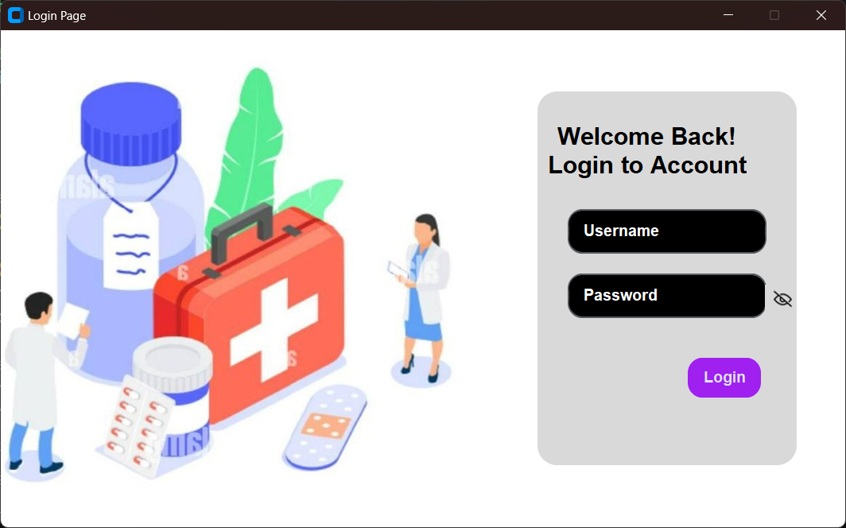

FIGURE (4.1) Login Page.

* **Functionality**
* **Username Input:** Users enter their registered username in this field.
* **Password Input:** Users enter their corresponding password in this field. The input field should obscure the entered characters (typically with asterisks) for security.
* **Password Visibility Toggle:** The eye icon in the password field allows users to temporarily reveal the entered password, aiding in accurate entry.
* **Login Button:** Clicking the "Login" button triggers the authentication process.

➢ ***PHARMACY HOME PAGE:***

* The Admin Page which will show if you logged in as an admin is designed to manage various functionalities of a medical or healthcare management system. It includes user details, navigation buttons, and a workspace area. This document describes the layout and functionality of the user interface elements.
* 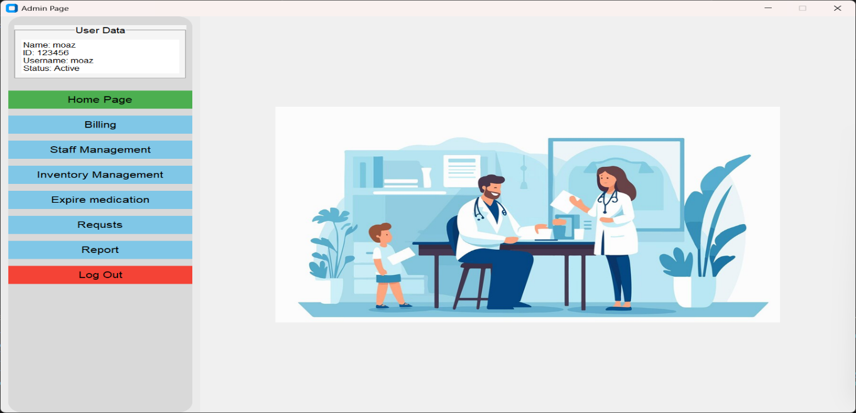The Staff Page which will show if you logged in as a Staff is designed to manage less functions because of authorization model.

*FIGURE (4.2) Home Page for admin*

* The interface is divided into the following sections:

1. **User Data Panel**:
   * Located in the top-left corner.
   * Displays user information such as:
     + **Name**: The user's full name.
     + **ID**: The user's unique identifier.
     + **Username**: The username associated with the account.
     + **Status**: Indicates whether the account is active or inactive.
2. **Navigation Menu**:
   * Positioned vertically on the left side of the screen.
   * Contains the following buttons:
     + **Home Page**: Redirects to the homepage.
     + **Billing**: Opens the billing module.
     + **Staff Management**: Manages staff-related details.
     + **Inventory Management**: Tracks and organizes inventory.
     + **Expire Medication**: Monitors and handles expired medication.
     + **Requests**: Manages user or system requests.
     + **Report**: Generates and views reports.
     + **Log Out**: Logs the user out of the system.
   * The buttons are color-coded:
     + Green for the current/active page.
     + Blue for inactive pages.
     + Red for critical actions like logging out.
3. **Workspace Area**:
   * Located on the right side of the screen.
   * Used to display the content corresponding to the selected navigation button.
   * Displays appropriate forms, tables, or visuals depending on the feature being used.

* **Functionality**
* **User Data Panel**
* Displays relevant user information to confirm the logged-in identity.
* Static and can’t be edited.
* **Navigation Menu**
* **Home Page**: Returns the user to the dashboard or main interface.
* **Billing**: Allows the user to manage transactions and invoices.
* **Staff Management**: Facilitates adding, removing, or editing staff details.
* **Inventory Management**: Provides tools to manage the stock of medical supplies.
* **Expire Medication**: Highlights and processes expired medication items.
* **Requests**: Handles user or system-generated requests for review or action.
* **Report**: Generates comprehensive system or user activity reports.
* **Log Out**: Ends the session and redirects the user to the login page.

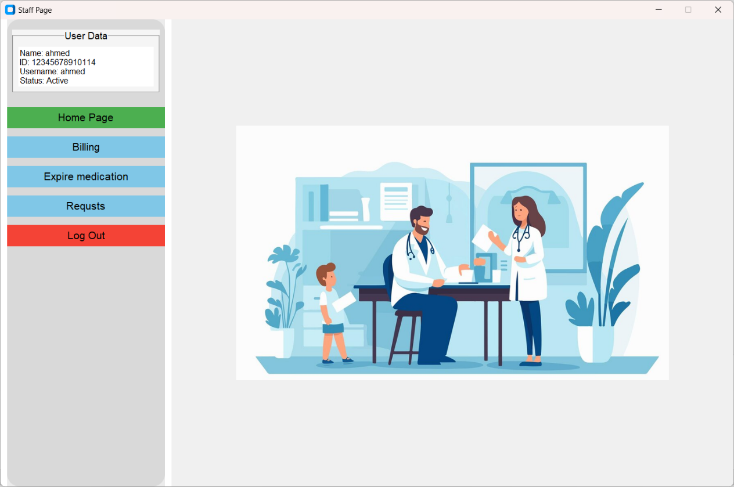

*FIGURE (4.3) Home Page for staff*

➢ ***BILLING SYSTEM PAGE:***

* The Billing System is accessible via the "Billing" button in the navigation menu. It allows users to manage product transactions by adding items to an invoice and calculating totals.

The interface is divided into the following sections:

1. **Product Input Section**:
   * Contains fields to enter product details:
     + **Product ID**: A text field for entering the unique identifier of the product.
     + **Product Quantity**: A text field for specifying the quantity of the product.
   * Validation messages (e.g., "the ID valid," "the quantity valid") appear below the respective fields in green to confirm correct input and it will disappear after a few seconds.

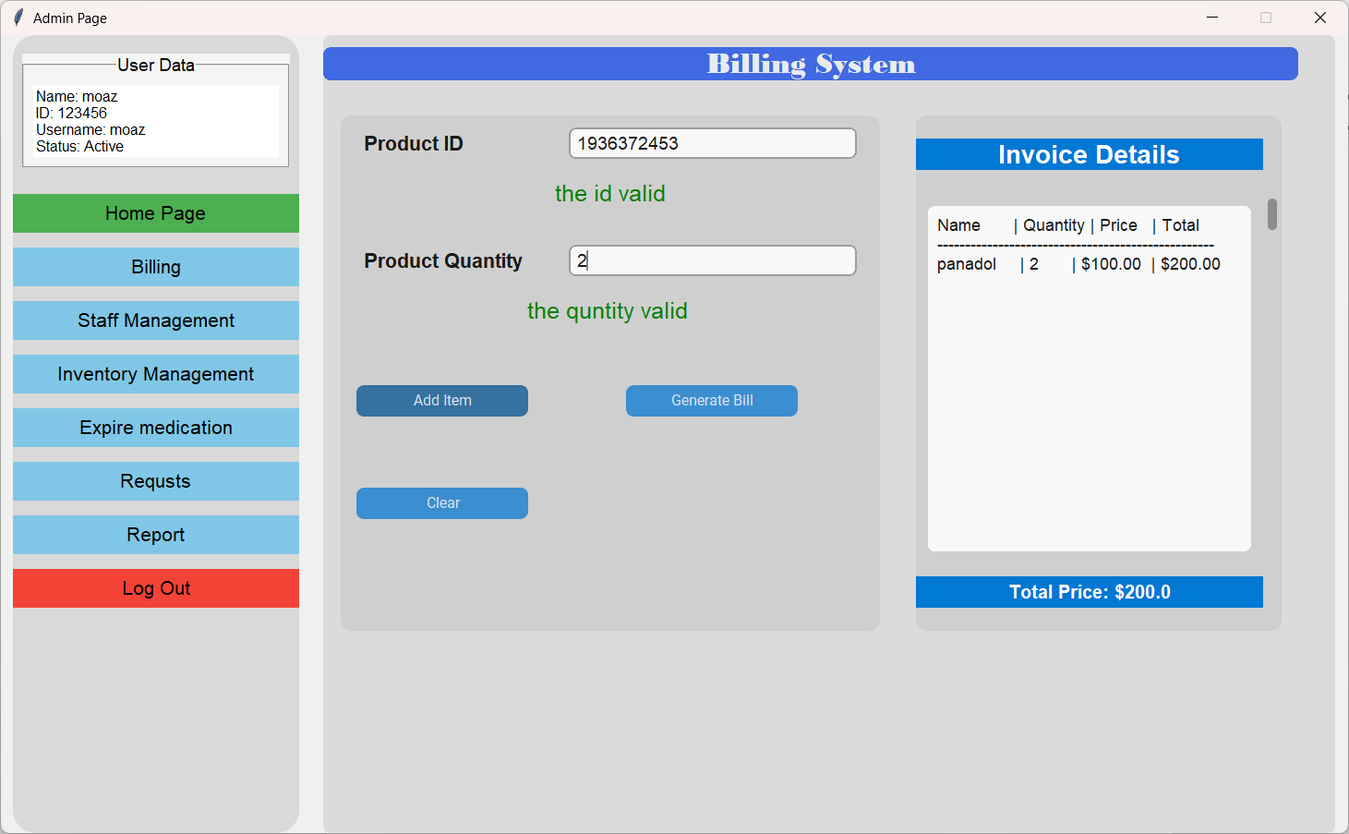

*FIGURE (4.4) Billing System*

1. **Action Buttons**:
   * **Add Item**: Adds the entered product and quantity to the invoice.
   * **Generate Bill**: Finalizes the invoice and calculates the total price.
   * **Clear**: Clears the current input fields for new entries.
2. **Invoice Details Panel**:
   * Displays a table with the following columns:
     + **Name**: The name of the product.
     + **Quantity**: The quantity of the product.
     + **Price**: The price per unit.
     + **Total**: The total cost for the product (quantity × price).
   * A blue bar at the bottom displays the **Total Price** of all items in the invoice.

➢ ***STAFF MANAGEMENT PAGE:***

* Staff management is about organizing and supervising employees to ensure they work efficiently. It includes tasks like working hours of each staff, and managing salaries. A good system makes these tasks easier and helps the organization run smoothly.

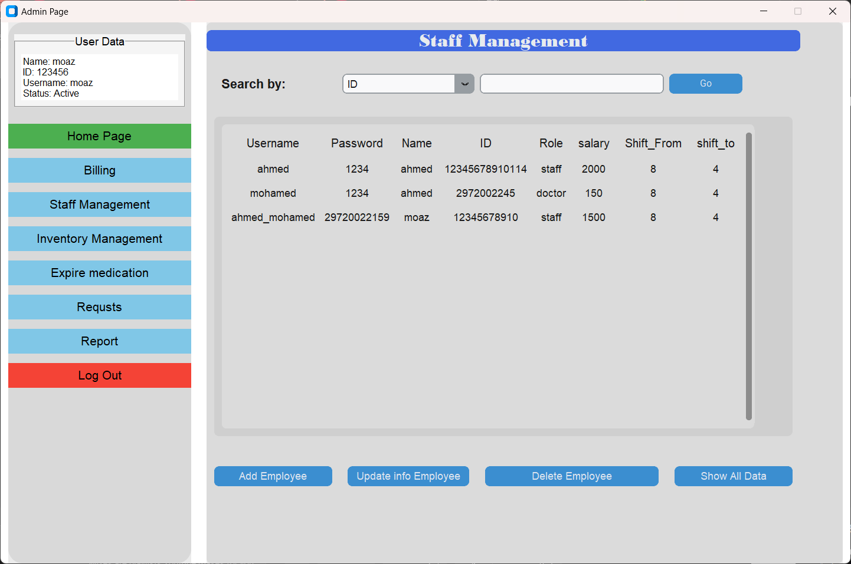

*FIGURE (4.5) Staff Management*.

* The interface is divided into the following sections:

1. **Search Function Section**:
   * Contains fields to search for staff details by:
     + **User ID**: A text field for entering the unique identifier of the user.
     + **User Name**: A text field for entering the username of the user.
2. **Data Display** **Function Section**:

* View detailed employee information in a structured format :
  + **Username**
  + **Password**
  + **Name**
  + **ID**
  + **Role (admin, staff, doctor)**
  + **Salary**
  + **Shift details (start and end times)**

1. **Staff Management** **Function Section**:

* **Add Employee**: Include new staff members into the database and requires all data employee to complete process of adding a new employee as shown in **figure (4.6)**

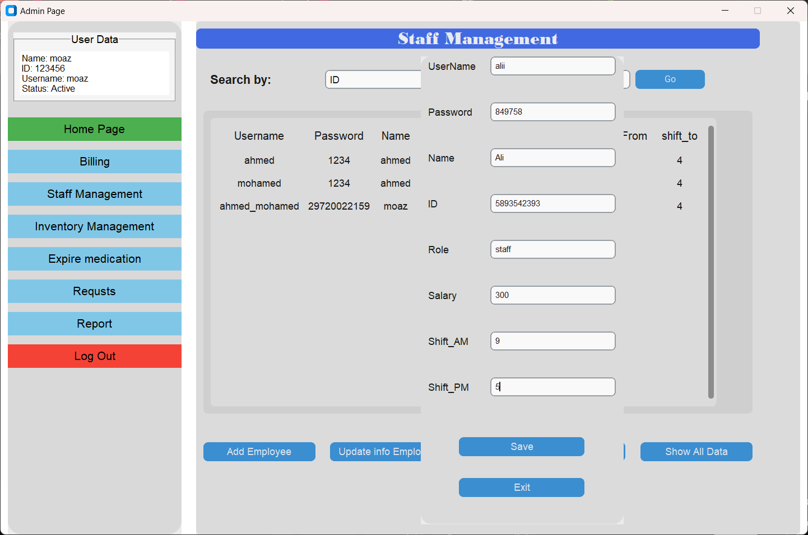

*FIGURE (4.6) Add Employee in Staff Management*.

* **Update Info Employee**: Edit existing employee details asking for User id or User Name.
* **Delete Employee**: Remove inactive employees from the system asking for User id or User Name.
* **Show All Data**: Shows all data in Staff Management database which provides an easy way to see all data.

➢ ***INVENTORY MANAGEMENT PAGE:***

* Inventory management focuses on tracking and organizing items to ensure accurate stock levels and proper operations. The system allows adding, updating, deleting, and displaying medication details efficiently, helping the organization manage its inventory effectively.

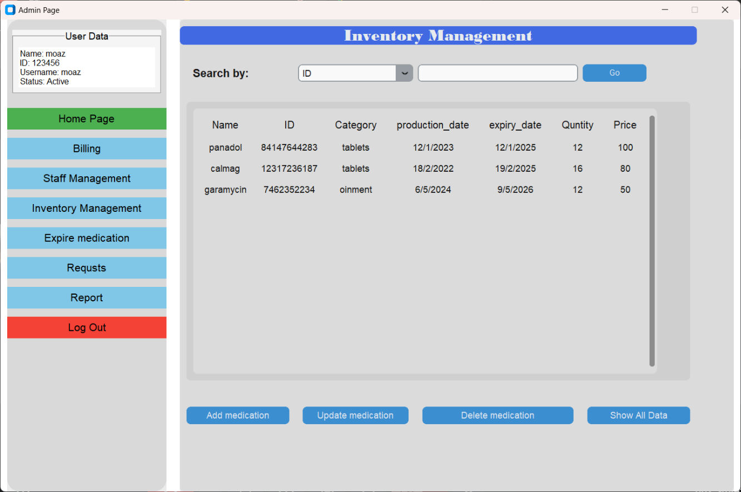

*FIGURE (4.7) Inventory Management*.

* The Interface is divided into the following sections:

**1.** **Search Function Section**:

* + Contains fields to search for staff details by:
    - **User ID**: A unique identifier for each medication item.
    - **Category**: The category of the medication to quickly locate specific items.

**2. Data Display Section:**

* Displays detailed inventory information in a structured table format, including:
  + **Name**: The name of the medication.
  + **ID**: A unique identifier for the medication.
  + **Category**: The type of medication (e.g., tablets, syrup).
  + **Production Date**: The date the medication was manufactured.
  + **Expiry Date**: The date the medication expires.
  + **Quantity**: The current stock level.
  + **Price**: The price of the medication.

**3. Inventory Management Functions:**

* **Add Medication:** Allows the user to add new medications to the database. Requires all details needed.
* **Update Medication:** Enables editing details of an existing medication. Requires the ID of the medication to update fields such as quantity or expiry date.
* **Delete Medication:** Removes a medication entry from the database. Requires the ID of the medication to proceed as **figure 4.8**
* 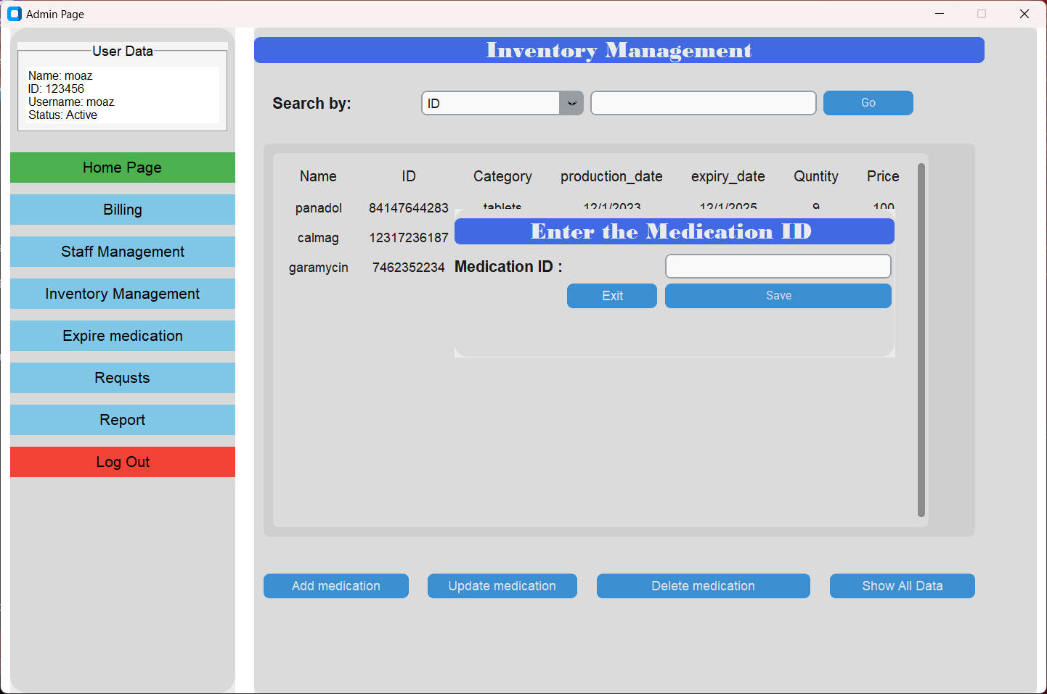**Show All Data:** Displays all inventory data in the system, providing an overview of all items.

*FIGURE (4.8) Delete Medicine from Inventory Management*.

➢ ***EXPIRED*** ***MEDICATIONS PAGE:***

* The expired medications feature ensures proper inventory control by identifying and managing items that are no longer usable. This functionality helps maintain compliance, avoid dispensing expired products, and ensures quality control.
* 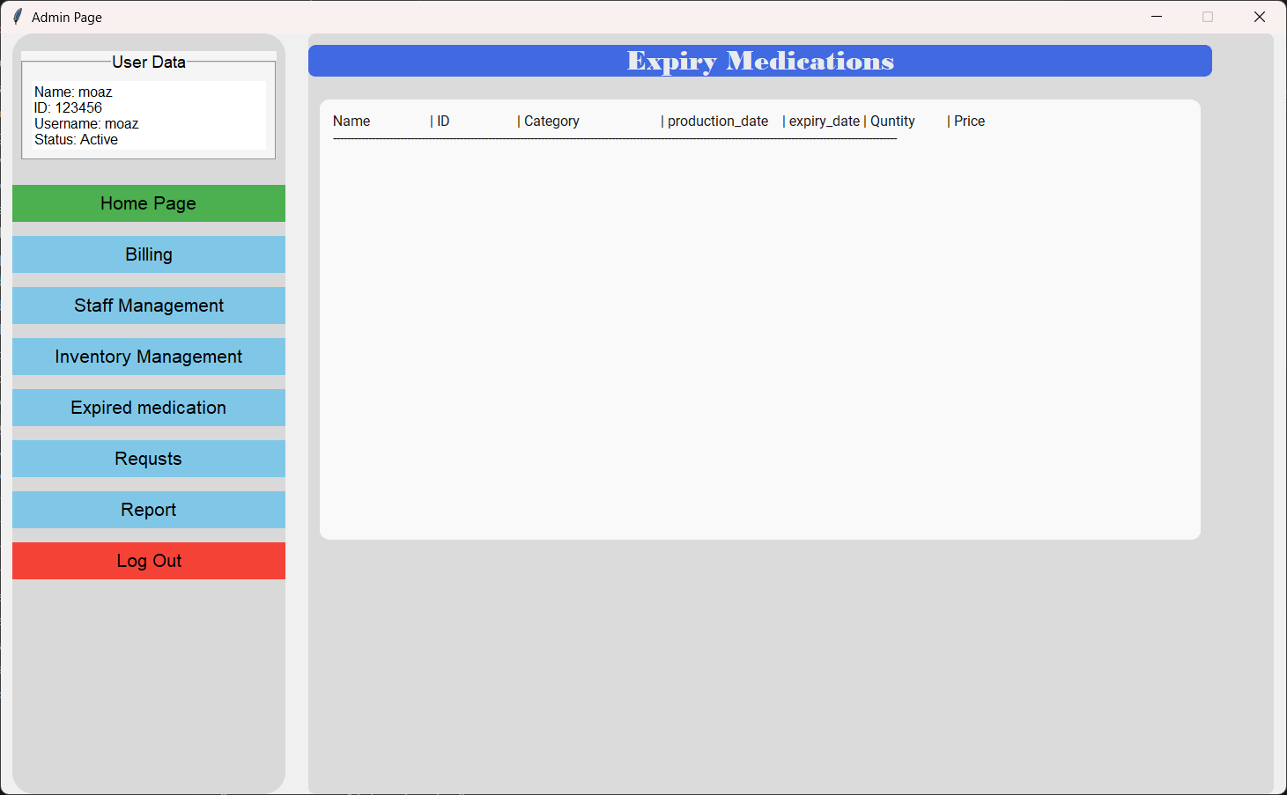The Interface is divided into the Following Sections:

*FIGURE (4.9) Expired Medications*.

**1. Data Display Section:**

* Displays information about medications that have passed their expiration date in a structured table format, including:
  + **Name:** The name of the medication.
  + **ID:** The unique identifier for the medication.
  + **Category:** The type of medication (e.g., tablets, syrup).
  + **Production Date:** The manufacturing date of the medication.
  + **Expiry Date:** The date the medication is no longer valid for use.
  + **Quantity:** The number of expired units available in the inventory.
  + **Price:** The cost of the expired medication.

➢ ***REQUESTS PAGE:***

* The Requests Dashboard facilitates communication between doctors and the pharmacy by processing medication requests. The system ensures accurate handling of prescriptions, streamlining pharmacy operations, and enhancing patient care.

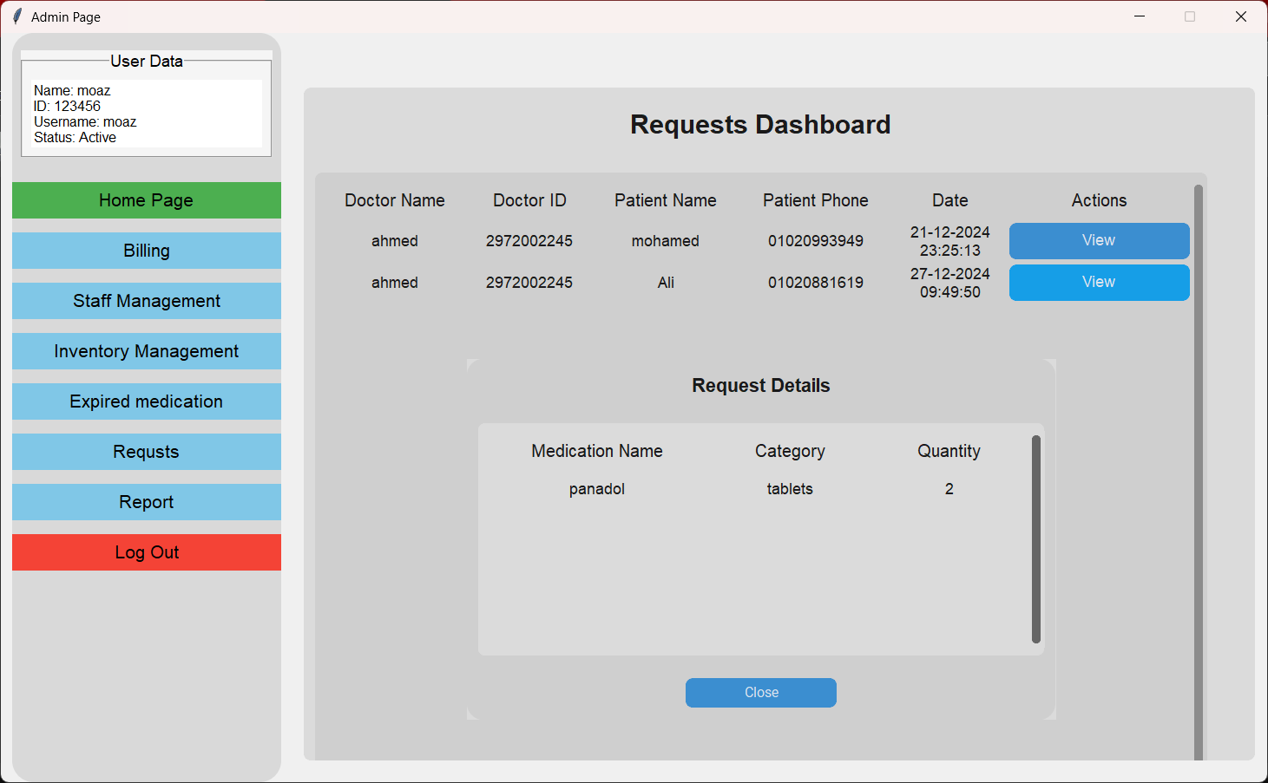

*FIGURE (4.10) Requests*

* The Interface is Divided into the Following Sections:
  1. **Requests Dashboard Section:**
  + Displays information about requests, including
    - **Doctor Name:** The name of the doctor who placed the request.
    - **Doctor ID:** A unique identifier for the doctor.
    - **Patient Name:** The name of the patient associated with the request.
    - **Patient Phone:** The contact number of the patient.
    - **Date:** The timestamp of when the request was made.
    - **Actions:** Provides a "View" button to see detailed information about the request.
  1. **Request Details Section:**
* **Purpose:** Displays specific details about a selected request.
* **Fields Included:**
  + **Medication Name:** The name of the requested medication.
  + **Category:** The type of medication (e.g., tablets, syrup).
  + **Quantity:** The number of units requested.
* **Action Buttons:**
  + **Close:** Closes the detailed view of the request.

1. **New Request Notification Feature:**

* **Purpose:** Alerts the user when a new medication request is received.
* **Functionality:**
  + When a new request arrives, the "Requests" tab in the navigation menu flashes red to grab the user's attention as **figure 4.11**
  + This flashing stops once the user views the new request or clicks on the "Requests" tab.
  + The flashing ensures urgent requests are not missed, improving response times.

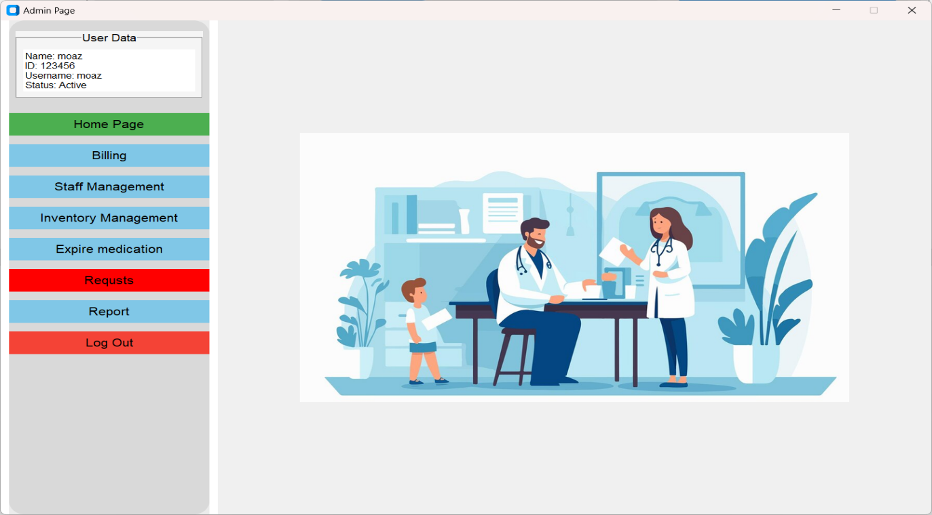**By streamlining the process of receiving and managing medication requests, the Requests Dashboard enhances the pharmacy’s operational efficiency and improves patient satisfaction.**

*FIGURE (4.11) Flashing Red Requests*.

➢ ***REPORT PAGE:***

* The Sales Report page provides a comprehensive view of all sales activities, including orders, quantities, and financial summaries. It helps organizations monitor performance, analyze trends, and improve operational efficiency.

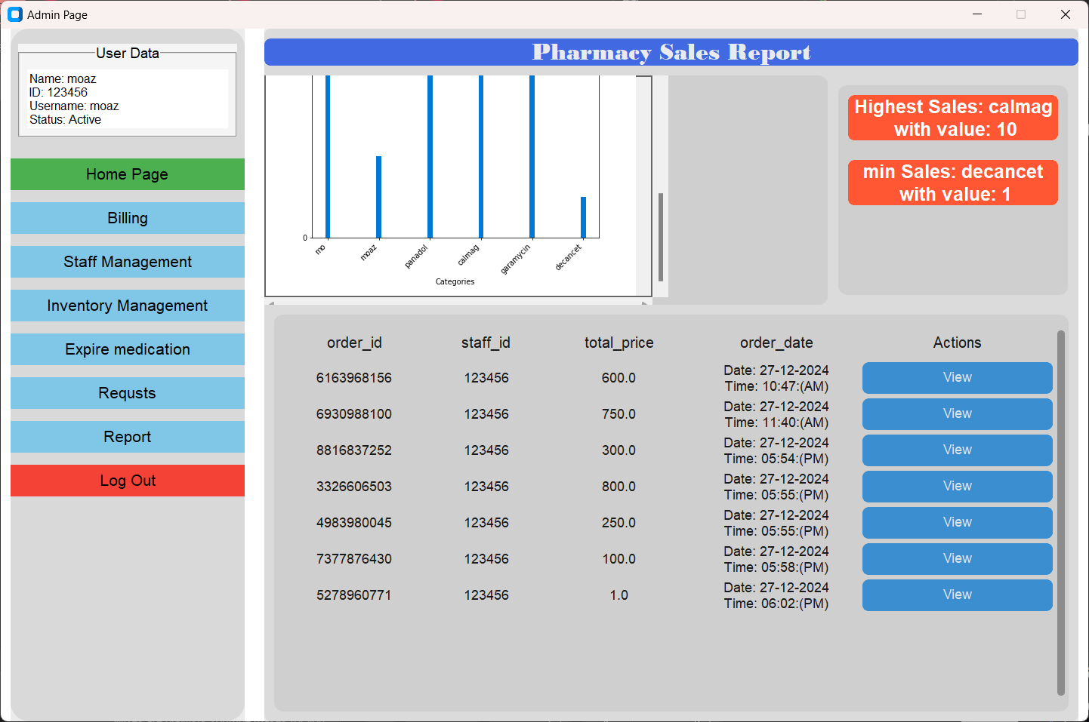

*FIGURE (4.12) Reports*.

* The Interface is divided into the Following Sections:

**1. Graphical Representation Section:**

* Displays sales performance using a bar chart for clear visualization:
* **Categories:** Represents medication names.
* **Values:** Reflects the total sales quantity for each medication.

1. **Highlights Section:**

* Provides quick insights into sales performance:
* **Highest Sales:** Displays the product with the highest sales quantity and its value.
* **Lowest Sales:** Displays the product with the minimum sales quantity and its value.

1. **Data Display Section:**

* Lists all sales records in a detailed, structured format, including:
* **Order ID:** The unique identifier for each sales transaction.
* **Staff ID:** The identifier of the staff member who processed the order.
* **Product ID:** The identifier of the medication sold.
* **Quantity:** The amount of medication sold in the order.
* **Price:** The price per unit of the medication.
* **Total Price:** The total cost of the order (quantity × price).
* **Order Date and Time:** The exact date and time the order was processed.

**By offering detailed insights and easy-to-read sales data, the Sales Report page improves operational transparency and supports better planning.**

➢ ***ELECTRONIC PRESCRIPTION PAGE:***

* The Electronic Prescription page enables doctors to create and send prescriptions directly to the pharmacy. This page ensures seamless communication between doctors and pharmacies, streamlining the medication dispensing process. You must log in as a doctor to access this page.
* The Interface is divided into the Following Sections:
  1. **Prescription Details Section:**
* Fields to input essential prescription details:
* **Customer Name:** The name of the patient.
* **Phone Number:** The patient’s contact number.
* **Medication Name:** The name of the prescribed medication.
* **Medication Quantity:** The number of units required.
* **Medication Category:** The type or form of the medication (e.g., tablets, syrup).

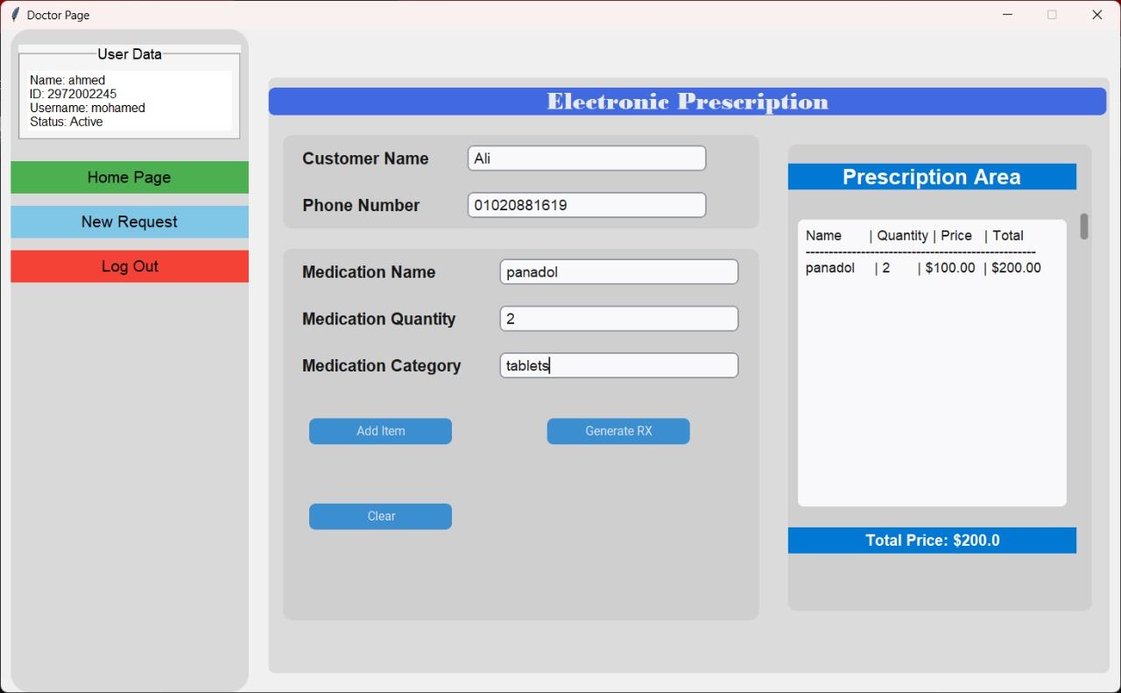

*FIGURE 4.9 Reports*.

* 1. **Action Buttons Section:**
* **Add Item:** Add the specified medication and its details to the prescription list.
* **Generate RX:** Finalizes and sends the electronic prescription to the pharmacy for processing.
* **Clear:** Resets all input fields to prepare for a new prescription.
  1. **Prescription Area Section:**
* Displays the list of medications added to the prescription, including:
* **Name:** The name of the medication.
* **Quantity:** The prescribed quantity.
* **Price:** The price per unit of the medication.
* **Total:** The total cost for the specific medication (quantity × price).

1. **Total Price Section:**

* Summarizes the total cost of all medications in the prescription, displayed at the bottom of the page.

**CLASS DIAGRAM**

|  |
| --- |
| **<<Object>>** |
| Staff |

|  |
| --- |
| **<<Object>>** |
| Doctor |

|  |
| --- |
| **<<Object>>** |
| Admin |

|  |
| --- |
| **<<Boundary>>** |
| Home page Interface |

|  |
| --- |
| **<<Boundary>>** |
| Home page Interface |

|  |
| --- |
| **<<Boundary>>** |
| Home page Interface |

|  |
| --- |
| **<<Boundary>>** |
| New Request Interface |

|  |
| --- |
| **<<Boundary>>** |
| Login Interface |

|  |
| --- |
| **<<Boundary>>** |
| Login Interface |

|  |
| --- |
| **<<Boundary>>** |
| Login Interface |

|  |
| --- |
| **<<Boundary>>** |
| Inventory Management Interface |

|  |
| --- |
| **<<Boundary>>** |
| Request Interface |

|  |
| --- |
| **<<Control>>** |
| Login Controller |

|  |
| --- |
| **<<Boundary>>** |
| Staff Management Interface |

|  |
| --- |
| **<<Boundary>>** |
| Expired Medication Interface |

|  |
| --- |
| **<<Boundary>>** |
| Billing Interface |

|  |
| --- |
| **<<Boundary>>** |
| Report Interface |

|  |
| --- |
| **<<Control>>** |
| New Request Controller |

|  |
| --- |
| **<<Control>>** |
| Report Controller |

|  |
| --- |
| **<<Control>>** |
| Inventory Management Controller |

|  |
| --- |
| **<<Boundary>>** |
| Expired Medication Interface |

|  |
| --- |
| **<<Boundary>>** |
| Request Interface |

|  |
| --- |
| **<<Control>>** |
| Staff Management Controller |

|  |
| --- |
| **<<Control>>** |
| Billing Controller |

|  |
| --- |
| **<<Control>>** |
| Expired Medication Controller |

|  |
| --- |
| **<<Control>>** |
| Request Controller |

|  |
| --- |
| **<<Boundary>>** |
| Billing Interface |

**SEQUENCE DIAGRAM**

1. **Login as Admin**

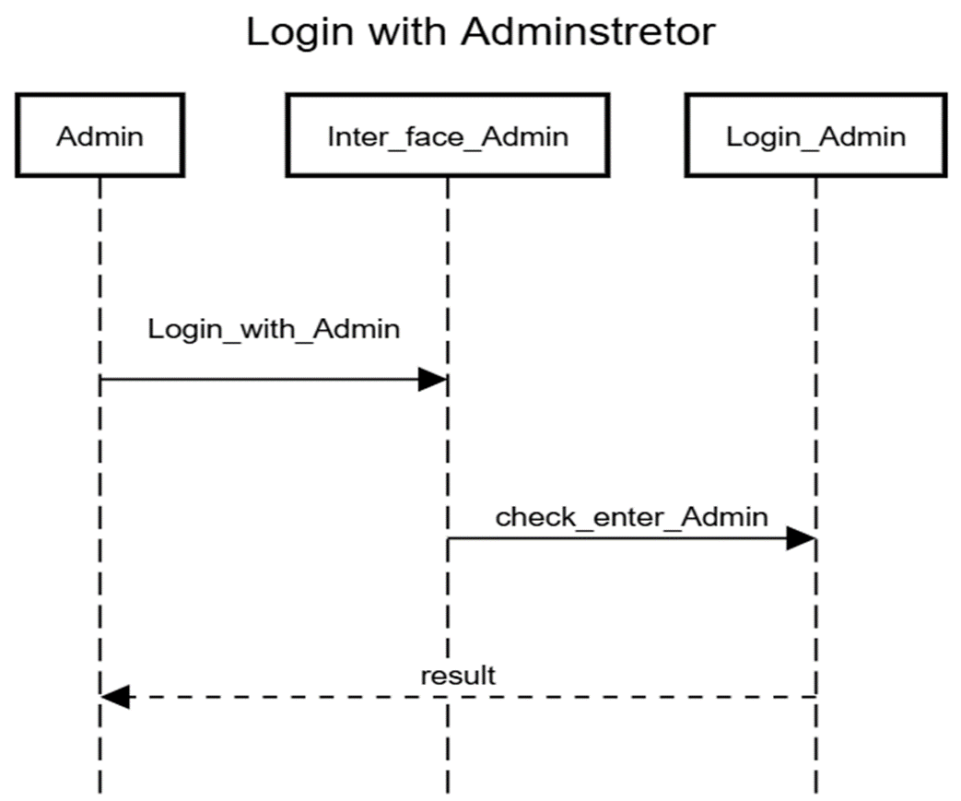

1. **Add new employee**

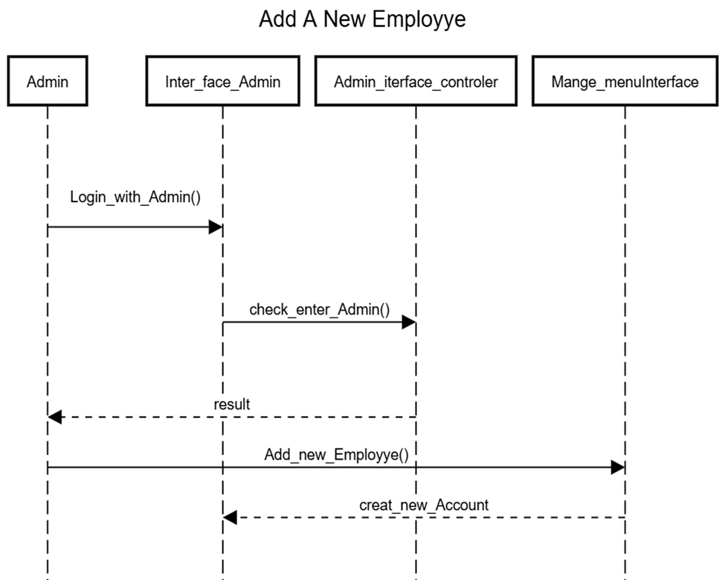

1. 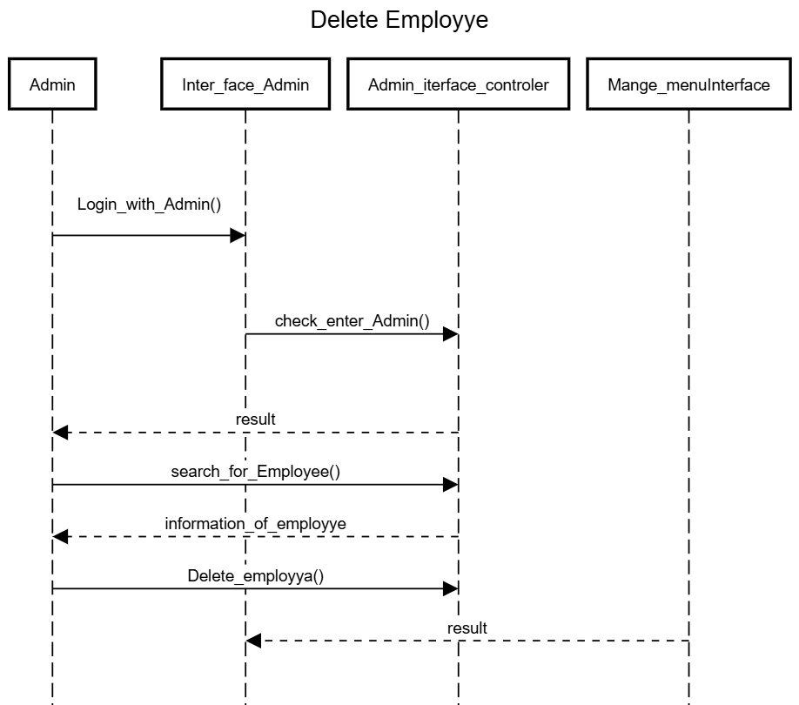**Remove employee**

1. 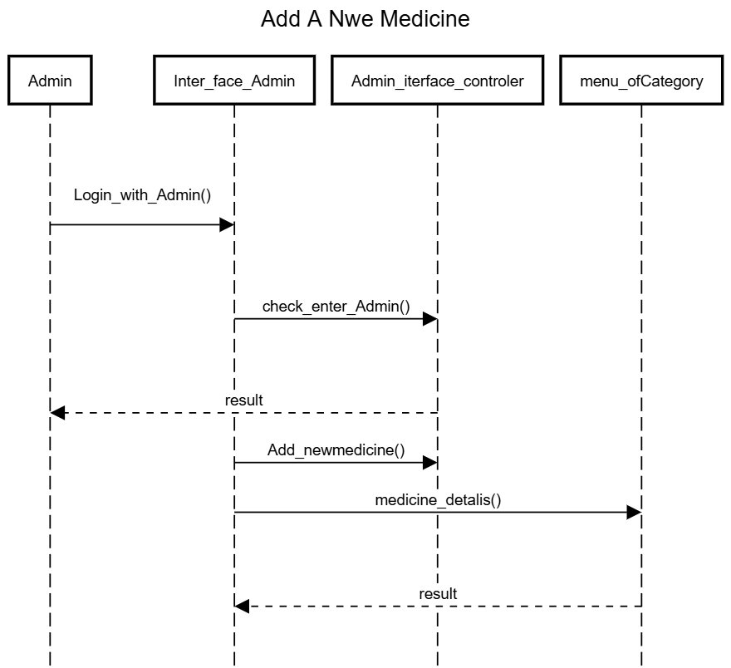**Add new medicine**

Add New medicine

1. 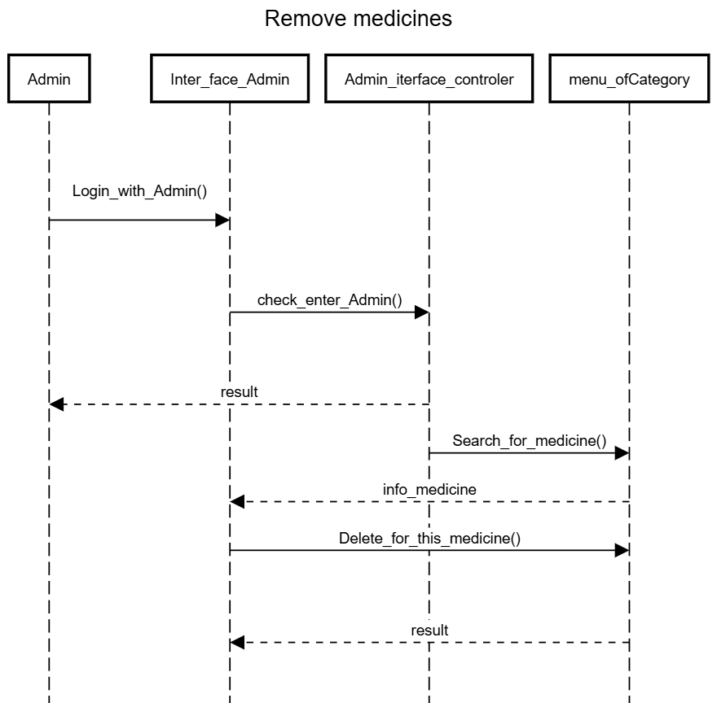**Remove medicine**
2. **Login as Doctor:**

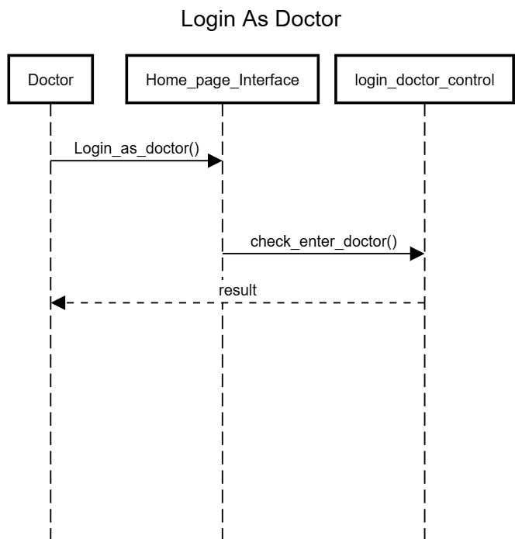

1. **Create Request By Doctor:**

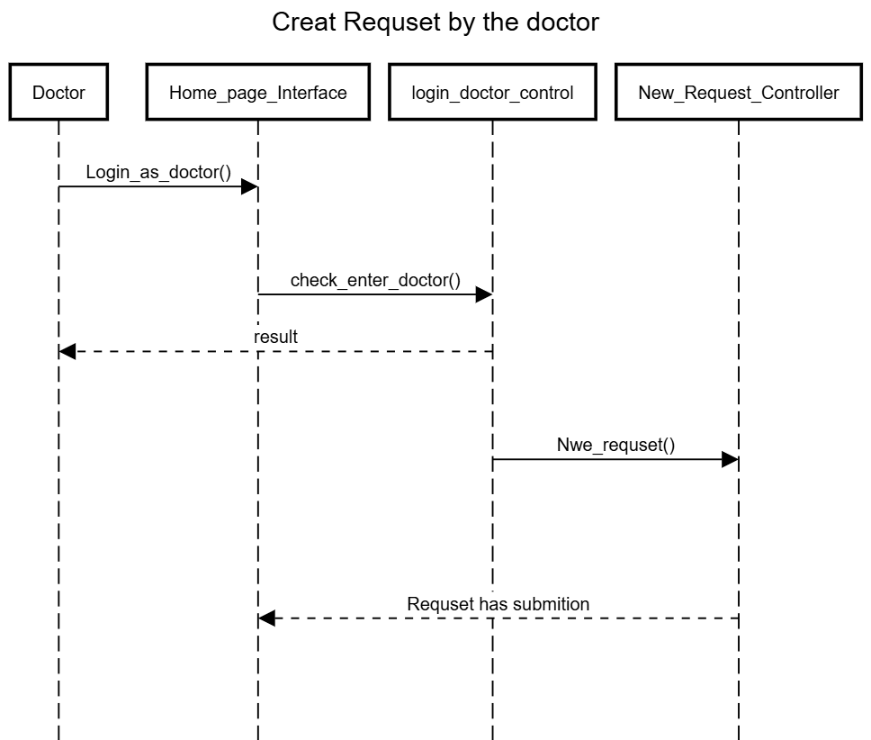

1. **Login as Staff:**

Create Request by Doctor

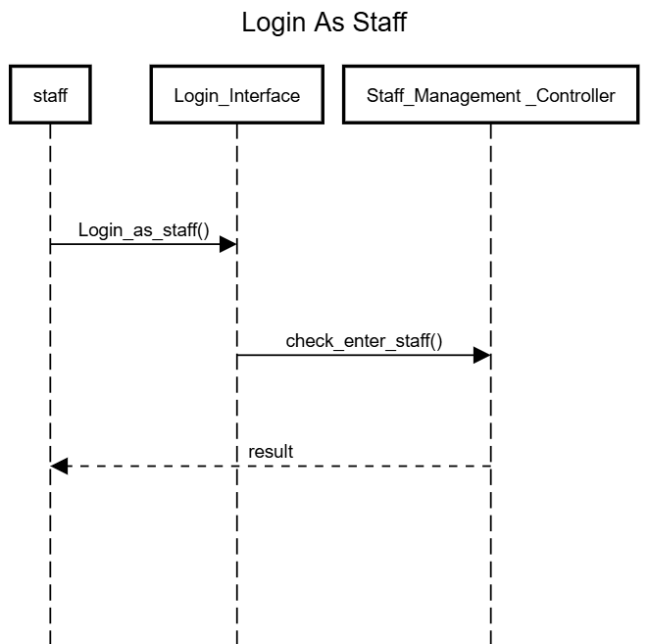

1. **Create Report:**

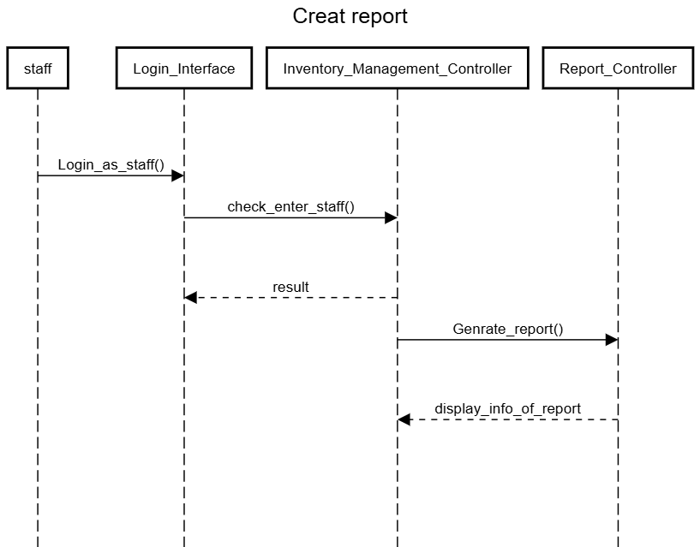

Create Report

1. **Generate Billing:**

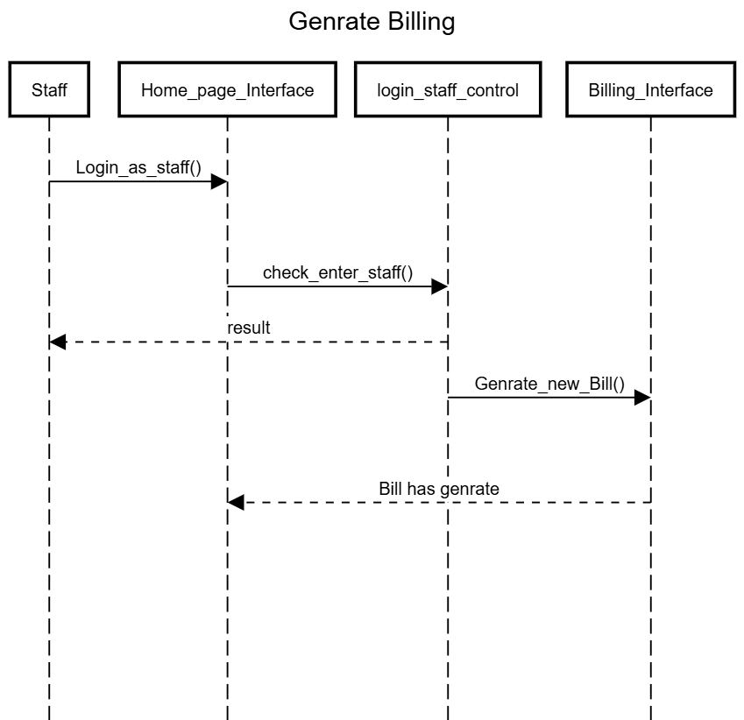

**Pharmacy Management System Data**

**Flow Diagram (DFD)**

A thorough explanation is provided for the example **data flow diagram for pharmacy management system**. This example emphasizes the three **DFD levels (DFD Levels 0, 1, and 2)**.

1. **Level DFD for Pharmacy Management System**

The context diagram is an alternative name for the **Pharmacy Management System DFD Level 0**. Users, the main process, and data flow make up its parts. Also, the project concept is demonstrated using the single process visualization.

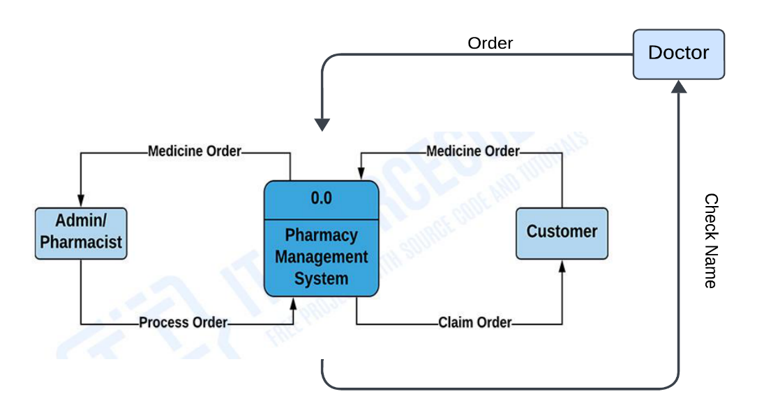 **Figure (7.1)** shows the entities that interact with a system and defines the border between the system and its environment. This diagram also depicts the pharmacy management system at a high level.

*Figure (7.1) 0 Level DFD for Pharmacy Management System*

The illustration presents the main process in a single node to introduce the project context. This context explains how the project works in just one look. The user feeds data into the system and then receives the output from it.

In addition to this, you will perceive through the diagram that there is already the presence of data flow. Though the process is very general, the flow of data is clear. Nevertheless, just modify this diagram to meet the other requirements and include other matters regarding pharmacy management.

**Level 1 DFD for Pharmacy Management System**

The "detonated view" of the context diagram is **Pharmacy Management System** **DFD Level 1**. Its function is to deepen the concept derive from the context diagram.

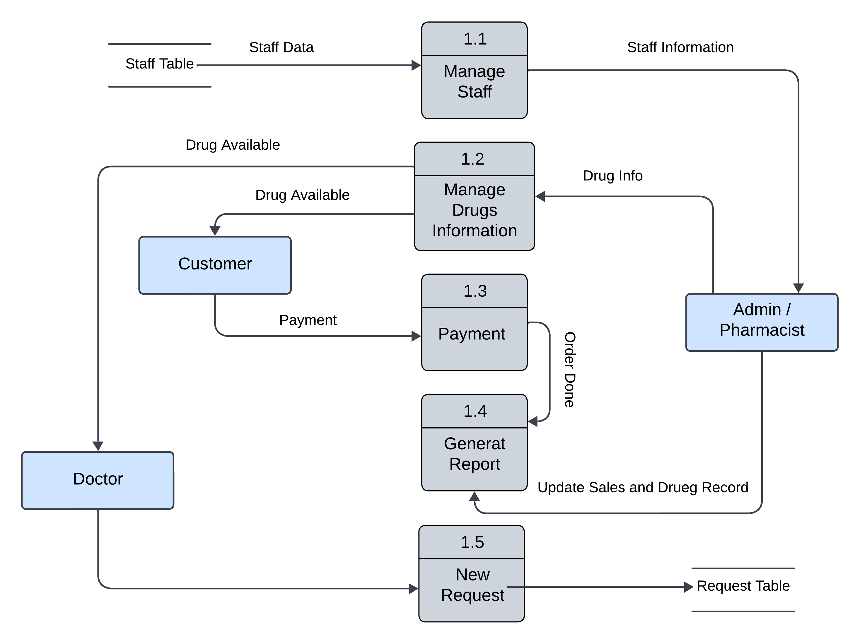 Specifically, **Figure (7.2)** shows the broader details of Pharmacy Management System DFD Level 0. This is to clarify the paths (flow) of data and its transformation from input to output.

*Figure (7.2) Level 1 DFD for Pharmacy Management System*

The designed diagram portrays five different scenarios: manage staff, order or reservation management, manage drugs information, request management, and report and payments management.

Firstly, the flow of data starts from the pharmacy admin or owners and doctors and customers. Then the system return the medicine to the transaction. This idea was based on pharmacy management processes or transactions.

You can also see the data store used or the database. The database is also used in storing doctors’ data inputs. Then it serves as the source of outputs.

**Level 2 DFD for Pharmacy Management System**

**Management System DFD Level 2** is also the highest abstraction of the data flow diagram. This level also broadens the idea from the DFD level 1. It includes the sub-processes from level 1 as well as the data that flows.

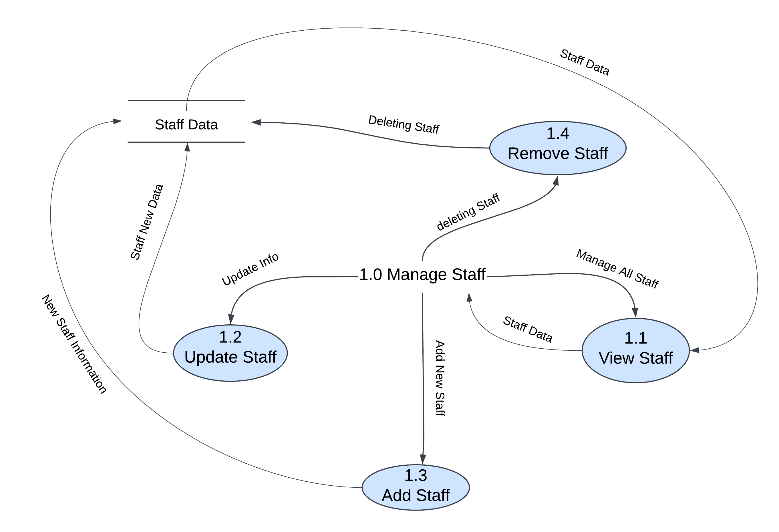

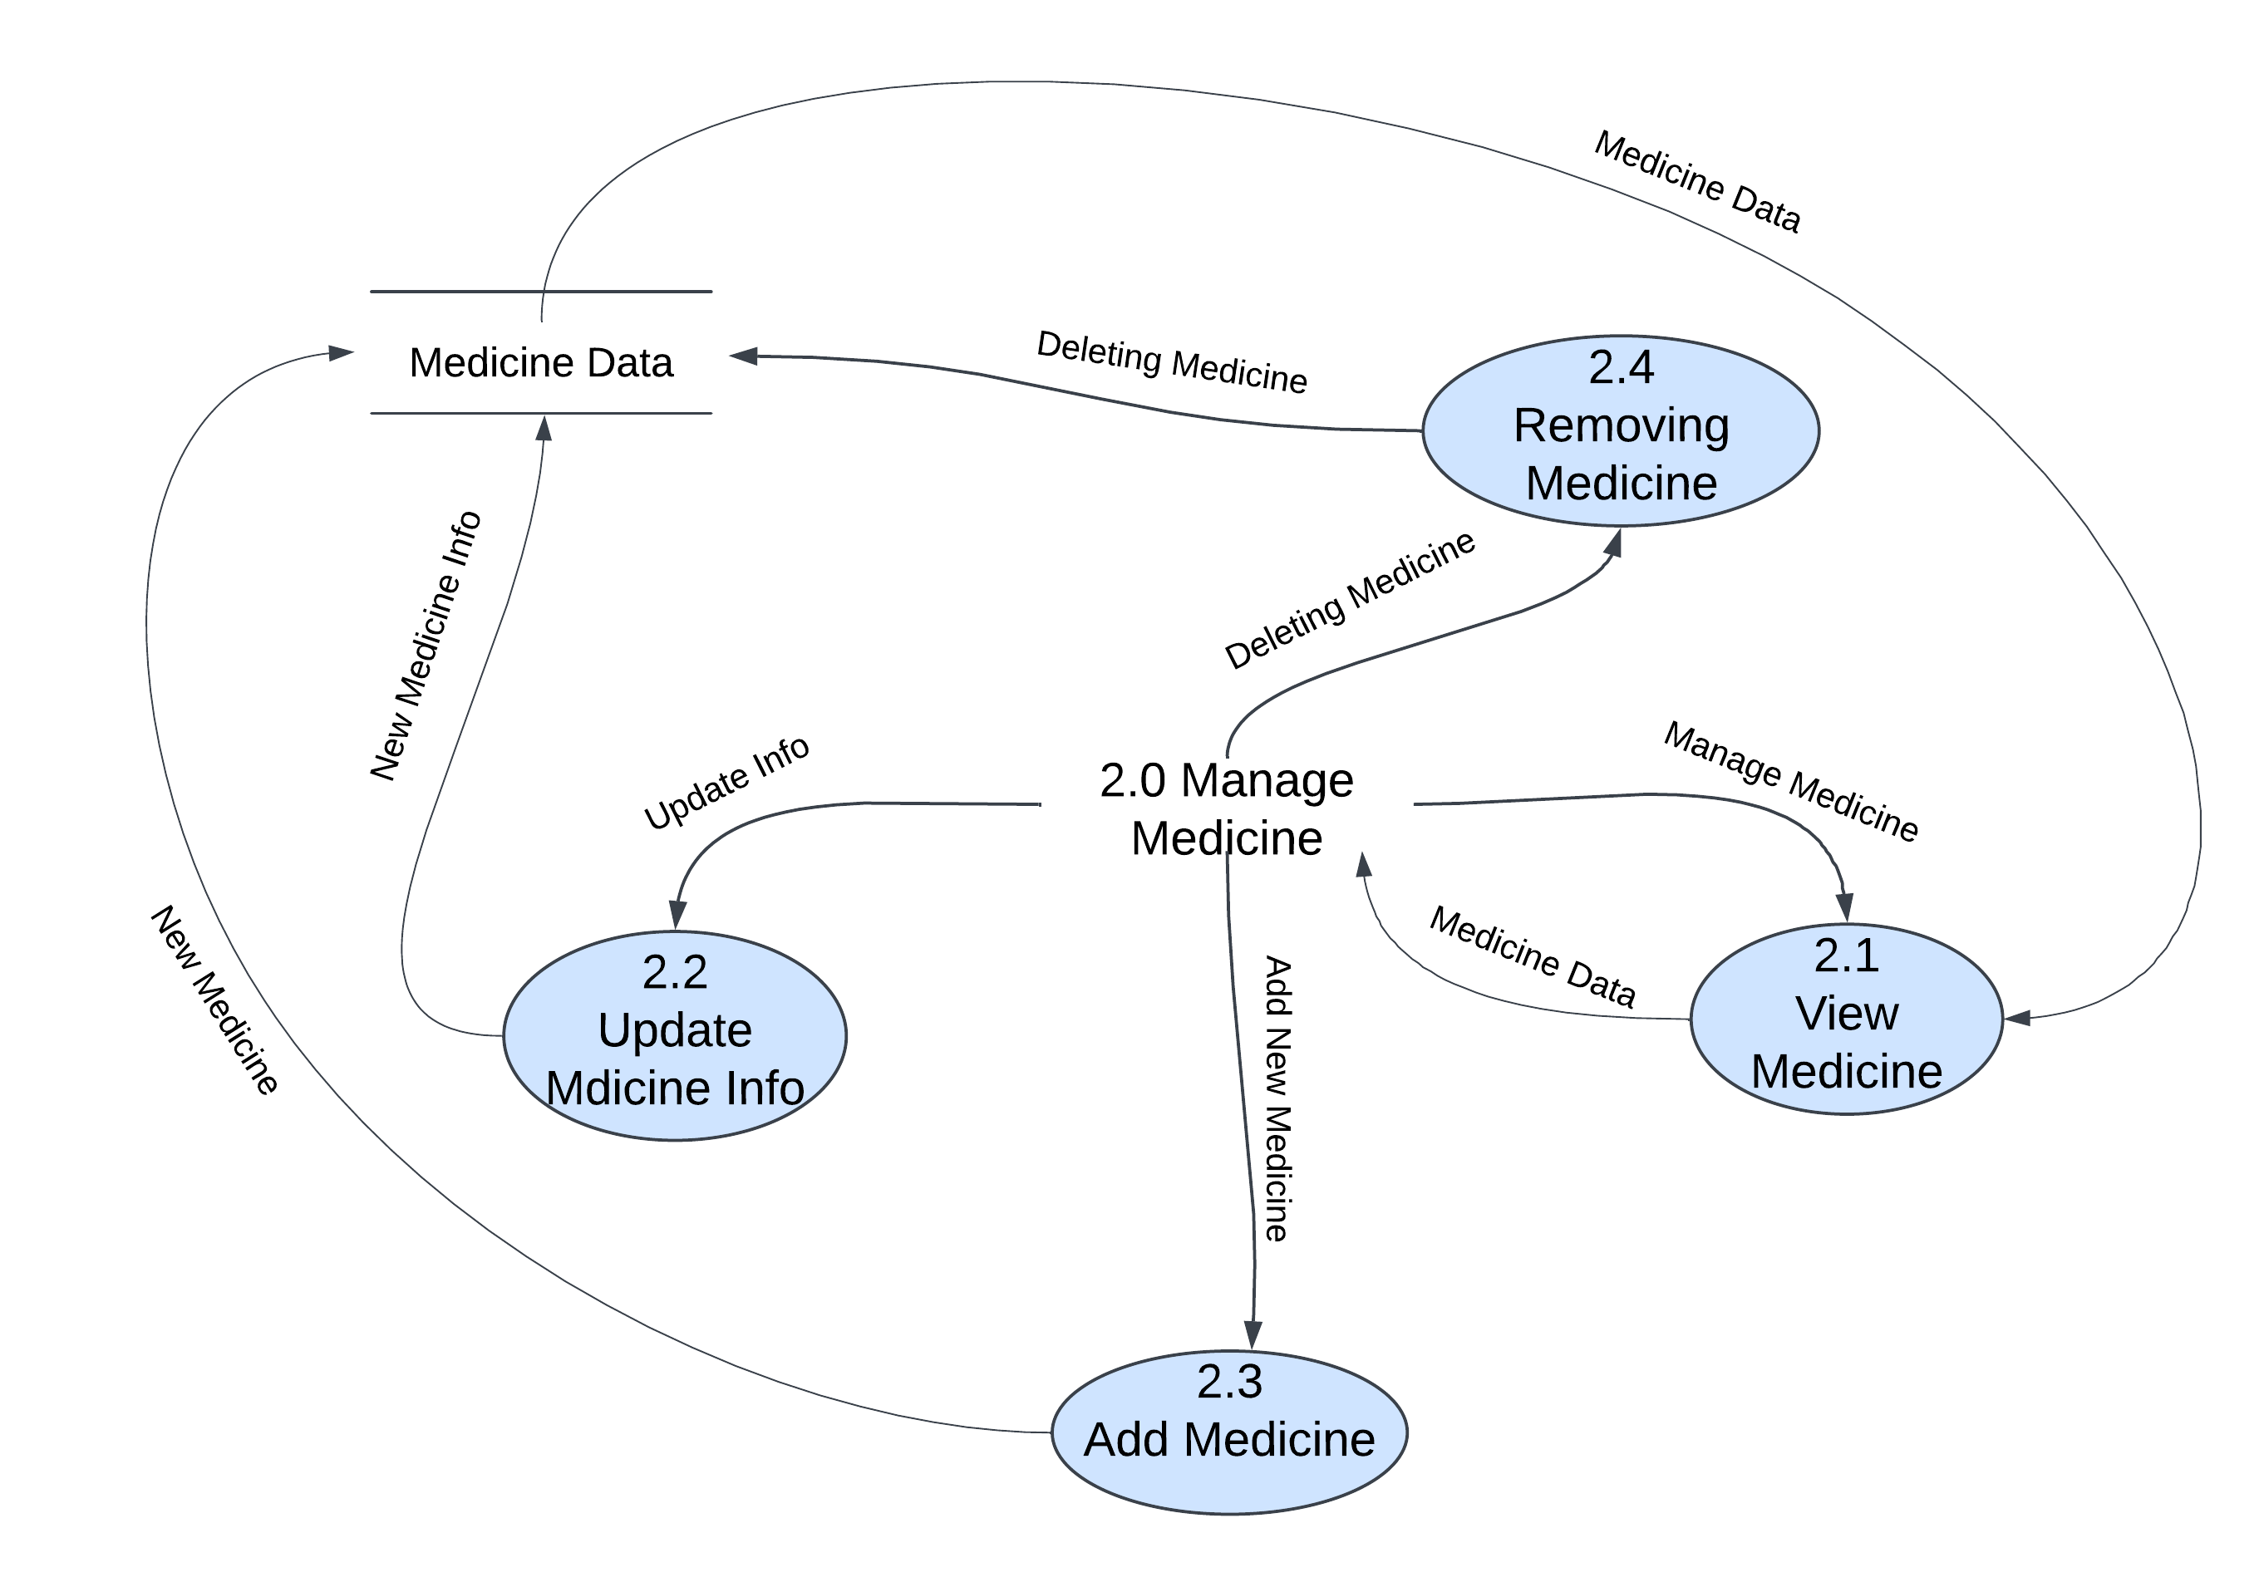

*Figure (7.3a) Level 2 DFD for Pharmacy Management System*

However, not all of the processes in the project must have sub-processes. Only provide this diagram if needed. As long as your previous diagrams were clear and precise, this level is not required.

You can add more to this and it is up to you how you will create your data flow diagram. Also, consider the data flow included and be precise with your information.

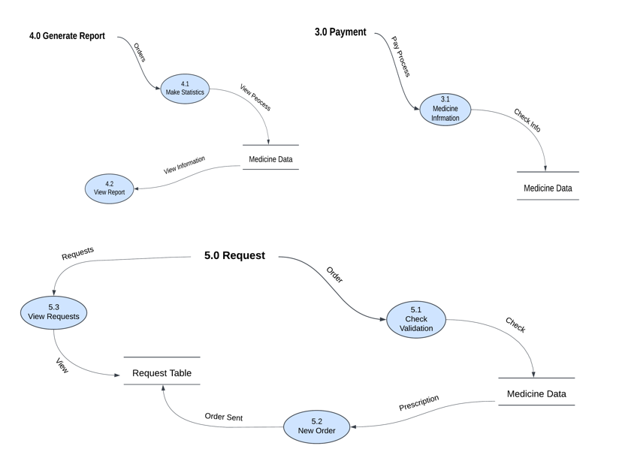

*Figure (7.3b) Level 2 DFD for Pharmacy Management System*

**PROCESS SPECIFICATION**

Table (8.1) update staff info

|  |
| --- |
| **Process description form**  ID: 1.2  Name: Update Staff  Description: update the any data of staff |
| Input data flow: staff ID and any data you want update |
| Output data flow: Update the data Successfully in database |
| Type of process  Online Batch Manual |
| Type of process  Structured English Decision table  Decision tree |
| Unresolved Issues: |

|  |
| --- |
| **Process description form**  Table (8.2) Remove staff Data  ID: 1.4  Name: Remove Staff  Description: Remove staff data |
| Input data flow: Staff ID or Username |
| Output data flow: Remove the data Successfully from database |
| Type of process  Online Batch Manual |
| Type of process  Structured English Decision table  Decision tree |
| Unresolved Issues: |

Table (8.3) Add Staff

|  |
| --- |
| **Process description form**  ID: 1.3  Name: Add Staff  Description: Add staff in system |
| Input data flow: the data for the staff(Name, id , Username, Password, Salary, Role, Shift) |
| Output data flow: Update the data Successfully in database |
| Type of process  Online Batch Manual |
| Type of process  Structured English Decision table  Decision tree |
| Unresolved Issues: |

Table (8.4) Add MEDs

|  |
| --- |
| **Process description form**  ID: 2.3  Name: Add Medicine  Description: Adding A new Medicine by the Adman or staff |
| Input data flow: information of a medicine and ID |
| Output data flow: New staff added successfully |
| Type of process  Online Batch Manual |
| Type of process  Decision Tree Decision table  Structured English |
| Unresolved Issues: |

|  |
| --- |
| **Process description form**  Table (8.5) Update MEDs info  ID: 2.2  Nam: Update Medicine  Description: updating medicine in database |
| Input data flow: a new information of a medicine |
| Output data flow: Updating this medicine |
| Type of process  Online Batch Manual |
| Type of process  Decision Tree Decision table  Structured English |
| Unresolved Issues: |

Table (8.6) Remove MEDs

|  |
| --- |
| **Process description form**  ID: 2.4  Nam: Removing Medicine  Description: Removing a medicine form database |
| Input data flow: information of a medicine and ID |
| Output data flow: Removing this medicine |
| Type of process  Online Batch Manual |
| Type of process  Decision Tree Decision table  Structured English |
| Unresolved Issues: |

|  |
| --- |
| **Process description form**  ID: 3.1  Name: Add Item  Description: Adding medicine being purchased to the bill |
| Input data flow: product Id and Quantity |
| Output data flow: Item added successfully to the bill |
| Type of process  Online Batch Manual |
| Type of process  Structured English Decision table Decision tree |
| Unresolved Issues: |

Table (8.7) Adding MEDs to bill

true

false

Item not found

Item found

Table (8.8) Clear invoice content

|  |
| --- |
| **Process description form**  ID: 3.2  Name: Clear invoice  Description: clear the current medicine in the input row |
| Input data flow: clear |
| Output data flow: Return the quantity in the bill in database |
| Type of process  Online Batch Manual |
| Type of process  Structured English Decision table Decision tree |
| Unresolved Issues: |

|  |
| --- |
| **Process description form**  ID: 3.3  Name: Generate bill  Description: confirms all the medicines to be purchased |
| Input data flow: Generate Rx |
| Output data flow: Generate the bill and save bill in database |
| Type of process  Online Batch Manual |
| Type of process  Structured English Decision table Decision tree |
| Unresolved Issues: |

Table (8.8) Generate Bill

false

true

|  |
| --- |
| **Process description form**  ID: 4.1  Name: Make statistics  Description: provides a comprehensive view of all sales activities |
| Input data flow: prescription |
| Output data flow: order sent |
| Type of process  Online Batch Manual |
| Type of process  Structured English Decision table Decision tree |
| Unresolved Issues: |

|  |
| --- |
| **Process description form**  ID: 5.3  Name: New Request  Description: Alerts the user when a new medication request is received |
| Input data flow: prescription |
| Output data flow: order sent |
| Type of process  Online Batch Manual |
| Type of process  Structured English Decision table Decision tree |
| Unresolved Issues: |

True

False

Data exists

Doesn’t exists